Effects of Temperate Woodland Size on the Abundance and Species Richness of Silphids
Taylor Hood – 840443
BSc (Hons) Wildlife Ecology and
Conservation, Year 3, June 2019
“A thesis submitted in partial fulfilment of
the requirements for the Bachelor of Science
degree in Wildlife Ecology and Conservation”



This dissertation is a product of my own work and is not the work of any collaboration. I agree that this dissertation may be available for reference and photocopying at the discretion of the College.

Signed:

Date:

Acknowledgements

I should like to thank my primary and secondary supervisors, Nicola Edwards and Dr Claire Creswell, for their assistance throughout the year. Further thanks are extended to Ashleigh Whiffin and Matt Esh of the Silphidae Recording Scheme for their advice and support prior to the commencement of the study.

Abstract
Woodland fragmentation is the cause of much biodiversity loss, especially among groups dependant on ephemeral resources. Many Silphidae are reliant on dead vertebrates for feeding and breeding, however such use is directed by the extent of the carrion pool, presence of scavengers, edge effects, and interior-exterior temperature fluctuations—all of which are governed by qualities of the surrounding landscape. Though considered habitat generalists, some Silphids show preferences for woodland. Larger woodlands are thought to provide the spatio-temporal heterogeneity to facilitate carrion use and control. The present study investigated the differences in woodland size (four woodlands of two size classes deemed ‘large’ or ‘small’) on abundance and species richness. Baited non-lethal pitfall traps, of which there were four at each site, were visited 28 times from June to July, with a total of 64 aged baits set. Non-toxic marking paint applications ensured no recounts occurred. Friedman testing showed a significant reduction in Silphids with site size for beetle abundance (p < 0.001) and species richness (p = 0.001), however post hoc analysis indicated that only one of the small woodlands, Skittle Green, was significantly different from the two larger woodlands, Adwell and Emmington. It is concluded that while suggestions for conservation in Oxfordshire can be extrapolated, the limited nature of the data, the omission of measurements for important ecological variables, and the ambiguous or contradictory nature of responses of Silphids to fragmentation are requiring of further research.
Key words: Silphidae, fragmentation, bait, abundance, species richness

Contents

Acknowledgements iii
Abstract iv
List of Figures vii
List of Plates viii
List of Tables ix
1 Introduction 1
1.1 Fragmentation: The Wider Context 1
2 Literature Review 3
2.1 Silphid Ecology 3
2.2 Effects of Fragmentation on Silphidae 6
3 Study Aims & Objectives 8
4 Methodology 8
4.1 Overview 8
4.2 Sites 8
4.3 Trap Design 9
4.3.1 Pitfall Construction & Installation 9
4.3.2. Bait 11
4.4 Sampling Silphids 12
4.4.1. Identification 12
4.4.2. Numbers 12
4.4.3. Placement & Arrangement 13
4.4.4. Study Duration & Sampling Timing 14
4.5 Statistical Analysis 15
5 Results 16
6 Discussion 20
6.1 Results & Theory 20
6.2 Sources of Error 23
6.3 Study Relevance & Limitations 25
6.4 Further Study 26
7 Conclusion 27
References 28
Appendices 35
[A] Site and Trap Details 35
[B] Woodland/Site Photography & Other Information 36
[C] Raw Data 47
[D] Test Outputs & Post Hoc Methodology 50
[E] Site Access & Health and Safety 53

List of Figures
Figure 1 – Site locations and sizes 9
Figure 2 – Approximate placement and arrangement of pitfall traps 14
Figure 3 – Overall silphid count per site 16
Figure 4 – Silphid species totals 17
Figure 5 – Average catch per visit 17
Figure 6 – Post hoc analysis for silphid abundance 18
Figure 7 – Post hoc analysis for silphid species richness 19
Figure 8 – Nicrophorus humator records 41
Figure 9 – Nicrophorus vespilloides records 41
Figure 10 – Oiceoptoma thoracicum records 41
Figure 11 – Site surroundings and woodland extent 42
Figure 12 – House/Small 1 designations 43
Figure 13 – Skittle Green/Small 2 designations 44
Figure 14 – Emmington/Large 1 designations 45
Figure 15 – Adwell/Large 2 designations 46

List of Plates
Plate 1 – Aerial view of installed pitfall trap (without cover) 10
Plate 2 – Pitfall trap with secured cover 11
Plate 3 – Inaccessible perimeter of ‘House’ woodland 36
Plate 4 – Dense vegetation structure of ‘House’ woodland 36
Plate 5 – Young trees & dense vegetation structure of ‘House’ woodland 37
Plate 6 – Edge of ‘Skittle Green’ woodland 38
Plate 7 – Interior of ‘Emmington’ woodland 39
Plate 8 – Structure of ‘Adwell’ woodland 39

List of Tables
Table 1 – Beetle abundance output 19
Table 2 – Beetle species richness output 19
Table 3 – Distance matrix (Miles) 35
Table 4 – Pitfall trap positions 35
Table 5 – Silphid Data Sheet 47
Table 6 – Example of post hoc differences matrix 52
Table 7 – Z Table (Threshold Value) 52
Table 8 – Example of post hoc letters application 52
Table 9 – Example of post hoc letters simplification 52

1 Introduction
Biodiversity loss, and the subsequent reduction in the efficacy of ecosystem services it causes, is the single most important and wide-ranging issue in the spheres of politics, economics, and cultural heritage, among others, in our world today (Ninan, 2009).

1.1 Fragmentation: The Wider Context
Habitat fragmentation is one of the chief processes by which ecosystems face degradation. The most direct consequence of fragmentation, write Lindenmayer, Bennett and Hobbs (2010), is the gradual reduction of vegetation into patches of varying sizes and distances, all of which lead to an increase in non-habitat matrix and limited ecologically viable habitat. Reduction in habitat is a ubiquitous issue in ecological science and most taxa are affected in some way, but even groups as vagile as the Insecta are at high risk of population decline and loss of genetic variability (Schowalter, 2016). Didham (2010) cites five key drivers of fragmentation: reduced patch area, increase edge effects, modified patch shape, increased patch isolation and modified matrix structure. Consequences of these drivers are likely to include: alterations in regeneration niches and mortality and fecundity rates, increased susceptibility to events of stochasticity, limited residency of individuals, hampered species richness and abundance, and exacerbated or shifted microclimates (Wilson et al., 2016; Lindenmayer & Fischer, 2013).
Habitat fragmentation is intrinsically linked with land-use changes in increasingly altered landscapes, the historical study of which arose with MacArthur and Wilson’s Island Biogeography theory (IBT) (Didham, 2010). Of the many metrics attributable to habitats, this study focuses on size or area, for as the size of an island increases so does the number of species it can support, according to IBT (Woodland Trust, n.d.). Didham (2010) writes that where IBT utilised a probabilistic and neutral model to describe the colonization and extinction of species and communities, taking no account of life history traits or external factors prevalent in anthropogenically modified habitats, there is now a growing understanding of the importance of the fluidity of external influences, the internal dynamics within the patches themselves, and the blurring of boundaries between patch and matrix from the viewpoint of the organism of study. Today traits such as dispersal ability, diet, life span, and mode of reproduction are considered inseparable parts of a whole, and there is rising acknowledgement of the wider evolutionary response of species to fragmentation (Haddad et al., 2015). For example, in the UK there has been a change from piecemeal to integrated landscape-scale conservation as seen in initiatives such as Nature Improvement Areas, National Character Areas, Natural England’s The Mosaic Approach, and the current Biodiversity 2020 Strategy—all driven by the need to establish ecologically coherent networks and recognise the interdependence of economic, social and environment goals (Appleton et al., 2015). UK habitats are particularly fragmented and disparate; approximately 77% of Sites of Special Scientific Interest and 98% Local Wildlife Sites are smaller than 100ha (Appleton et al., 2015). Upwards of 37% of English forests are within 30m of the nearest edge and 74% within 100m of nearby edge habitat, the situation worsening for ancient woodlands, a trend which suggests that most sites are subject to detrimental edge effects resulting from decreased size (Riutta, Slade, Morecroft, Bebber & Mahli, 2014).
Several studies have shown that larger contiguous forests contribute significantly more to Coleopteran biodiversity in comparison to smaller fragmented forests. For example, Pavuk and Wadsworth (2013) found that Cerambycid species richness and abundance was significantly poorer in smaller forests, perhaps due to the restricted availability of biological resources. According to Gaublomme, Hendrickx, Dhuyvetter and Desender (2008) forest specialist Carabid abundance increases were correlated with distance from the forest edge, a function of patch size, whilst generalists were more prevalent in smaller fragments due to their greater dispersal and higher reproductive rates across the urban matrix of their study. Dung beetles (the majority of which belong to the Geotrupidae, Scarabaeidae, and Aphodiidae) are reliant on dung as an ephemeral resource for feeding and breeding and play a significant functional role in its removal and recycling (Hanski & Cambefort, 1991). Andersen (2003) showed that 10ha fragments of Amazonian rainforest had higher dung beetle abundance than 1ha fragments, the greater the extent of forest the more dung removed.
Availability of ephemeral resources such as dung is particularly influenced by the effects of fragmentation since with the rapid turnover in spatio-temporal dynamics consumers must disperse regularly and widely through to find new hotspots, an occurrence intimately directed by landscape structure and heterogeneity (Duthie, 2013). Another example is carrion. An animal death represents a discrete and distinct locus of opportunity and disturbance, a pulse of activity which by its temporary nature produces much interspecific and intraspecific competition (Benbow, Tomberlin and Tarone, 2016; Mondor, et al. 2012). The dispersal of nutrients derived from the carcass is driven by scavenging and predation, the spread of which increases the availability to plants and filters down to the corresponding trophic levels, thus facilitating ecological regeneration and a vital ecosystem service (Barton, Cunningham, Lindenmayer & Manning, 2012).
This overview, especially the latter examples, highlights the multitudinous effects of fragmentation. In the ecology of the Silphidae, the family about which this study is concerned, there is a marriage between all these concepts of habitat loss, fragmentation and use of scarce resources.

2 Literature Review

2.1 Silphid Ecology
Composed of approximately 210 species within two subfamilies, Nicrophorinae and Silphinae, and across 13 genera, carrion and burying beetles (Coleoptera: Silphidae) are a lesser known Staphylinoid group whose largely necrophagous habit facilitates beneficial ecosystem services such as the recycling of nutrients and, through direct predacious behaviour during interspecific competition, the reduction of carrion-associated Diptera, commonly Calliphoridae and Sarcophagidae (Jakubec & Růžička, 2015; Kalinová, Podskalská, Růžička & Hoskovec, 2009). The biology of Silphids, particularly regarding breeding and social behaviour, is extensive in the literature however relatively little attention has been placed on the ecology of the family. Outside the spheres of biology and ecology Silphids have significance in the study of forensic entomology due to their predictable participation in the stages of entomofaunal succession and are often used in a medico-legal context because of their ability to predict post-mortem interval (PMI) (Dekeirsschieter, Verheggen, Lognay & Haubruge, 2011; Gennard, 2007; Smith, 1986). Furthermore, as another ecosystem service, it is believed that Silphid feeding activities can reduce certain foci of infectious diseases to which humans are susceptible (Dekeirsschieter, Verheggen, Lognay & Haubruge, 2011).
According to Beutel, Leschen and Lawrence (2016), the subfamily Silphinae, of which there are 14 extant genera containing 112 species, exhibit greater generic diversity and range of distribution (with representatives on all continents save Antarctica) than the Nicrophorinae, and among higher Silphines there is much trophic diversification, e.g. phytophagous Aclypea and the mollusc-predating Dendroxena. In this way, the term ‘carrion’ beetle, though it is often used to refer to the family, is not all-encompassing and does represent all traits and behaviours (Dekeirsschieter, Verheggen, Lognay & Haubruge, 2011). Nicrophorinae are the less generically and geographically diverse of the two subfamilies (found primarily within the temperate northern Hemisphere), having only three highly specialised genera world-wide, only one of which is found in the UK, that of Nicrophorus (Capinera, 2008).
Beutal, Leschen and Lawrence (2016) write of the clear taxonomic dichotomy in the behavioural ecologies and life histories of those Silphids which are necrophagous: the ancestral strategy of non-existent parental care whereby eggs are deposited in or around the soil and then abandoned is associated with Silphinae, who primarily take carcasses >300g; whereas in Nicrophorinae there exists the derived habit of protectionary interment of carcasses of <100g and the ability for bi-parental conspecific care throughout all offspring developmental stages. As opportunities for the securing of carcasses are variable in space and time, and dictated by extreme competition, Nicrophorines seek to maximise their lifetime fitness with their present brood and thus exhibit strong care for their young, burying carcass in a subterranean chamber, stripping it of hair or feathers, shaping it into a ball and, finally, laying eggs within the soil so that the altricial larvae may feed upon it (Scott,1998). Release of sex pheromones and calls by males discovering new carcasses attracts female attention with the express purpose to mate, however males are similarly brought in and significant fighting usually occurs until a single pair can secure the carcass for interment at a safe location (Gennard, 2007). Greater flight mobility, accelerated larval development, and larger numbers allow competing Diptera to access and utilise carcasses quicker than these Silphids however the latter have more advanced sensory and locomotor faculties (Smith, 1986). Indeed, Nicrophorines utilising the highly sensitive chemoreceptors located on their antennal clubs can detect volatile chemicals released during decomposition within one day, thus avoiding heavy competition (Ratcliffe, 1996).
Soil type and substrate is particularly important for Nicrophines since their reproductive output is dependent on ease of interment and the suitability and stableness of the soil environment, and there is much discrimination among species (Jakubec & Růžička, 2015). In a European study, von hoermann et al. (2015) found preferences for loose, sandy soils and lower ambient temperatures are preferred.
The phenomenon of niche differentiation is particularly strong in Silphids because of the intense competition for ephemeral resources (Dekeirsschieter, Verheggen, Lognay & Haubruge, 2011). During a long-term study of two years, Anderson (1982) found that resource partitioning is undertaken at the subfamilial level via the selection of different carcass sizes (as discussed above), whereas at the level of the species coexistence is permitted through habitat specificity and seasonal variation. Anderson’s study cited competition for food as the chief actor in ecological character displacement found in Silphids.
Habitat (biotope) partitioning is a key differentiator regarding Silphids and their ecology. This effect is seen worldwide. According to Shubeck (1983) five out of eight species within a New Jersey wildlife refuge exhibited strong preferences, some favouring forest whilst others predominated fields. Lomolino and Creighton (1996) found that the endangered Nicrophorus americanus of the United States is highly dependent on forested ecosystems over grassland for breeding success, the overarching factor being substrate type Dekeirsschieter, Verheggen, Lognay & Haubruge (2011) catalogue and tabulate habitat differences/preferences for species in Western Europe. Here both subfamilies show a range of preferences, the primary three being forest, field and open areas. It is not simply horizontal partitioning which is seen in Silphidae; several studies have posited that ecological divergence exists at varying heights in forest canopies, potentially due to costs associated with searching for canopy carrion and competitional factors (Dyer & Price, 2013; Legros & Beresford, 2010)
Regarding temporal differences, in Ružicka’s (1994) study of 14 species there is a clear seasonal distinction, e.g. Thanatophilus sinuatus recorded from April, Silpha tristis appearing much later in June. Daily activity also differs. At this shortest temporal scale, Kocarek (2001) and Scott (1998) found that the majority of Silphids are nocturnal whilst some are diurnal or crepuscular.

2.2 Effects of Fragmentation on Silphidae
Trumbo and Bloch (2000) showed limited breeding success in smaller woodlands compared to larger woodlands, perhaps due to higher incidence of vertebrate scavenging. Furthering this, in a general study on carrion-related arthropods by Gibbs and Stanton (2001), species richness of carrion beetles in fragmented forests was found to be limited by up to one-third, abundance by two thirds. Those beetles found within fragments were generalists with reduced body plans. In a similar study, Wolf and Gibbs (2004) found strong evidence for the reduction in carrion beetle diversity in fragments when compared with that of other habitat types. Their pitfall trap study utilised supplementary experimental placement of mice carcasses and in doing so a link was found between interment of these baits and burying beetle diversity. They surmised that forest size/extent in general was the greatest influencer on species metrics, rather than urban forests, for example, simply being less ecologically favourable, e.g. an increase in impervious surfaces. Abundance was positively correlated with deciduous forest extent.
According to New (2010), habitat fragmentation affects carrion supply by altering landscape suitability to the resident vertebrates therefore the fates of Silphids and carrion-contributing vertebrates are intrinsically linked. Indeed, mesopredator populations in areas with reduced forest cover are likely to be the first to discover and remove mouse carcasses, outcompeting Silphids and other carrion utilizers due to prevalence of edge habitat, write DeVault, Olson, Beasley and Rhodes (2011). Fragmentation may also reduce breeding success and waste energy by redirecting Silphids to carcasses in areas unsuitable for burying, as in the case of accumulated roadkill or by new and impermeable understory growth in recently cleared forests, in addition to direct reduction through increased vehicle-related mortality (Brunelle & Catling, 2011). In a 2013 study from Japan, again open carcass burials increased with forest area whereas removal by vertebrate scavengers decreased with forest area, with additional baited traps showing a positive relationship between rate of burial and extent of forest (Sugiura, Tanaka, Taki & Kanzaki, 2013).
Further still, in a wider landscape analysis of Silphid abundance and species richness on carcasses of Sus scrofa von hoermann et al. (2015) found that the presence of the forest species N. humator was directly impacted by forest management, citing that extensive management of stands in age-class forests as the key detrimental factor. Their study postulates that such susceptibility to modification in this species presents it as a useful indicator of anthropogenic disturbance in the wider context of habitat fragmentation. Recently, with the growing emphasis on genetics, a satellite marker study examining the dispersal abilities of Silphids between woodland patches in Cambridgeshire found that N. vespilloides had significantly lower observed heterozygosity and limited gene flow despite the families’ general capability for long periods of sustained flight Pascoal and Kilner (2017). Pascoal and Kilner (2017) postulated that habitat fragmentation imposes dispersal barriers and suggest N. vepsilloides may be unwilling to travel through the hostile matrix of housing and open fields. Crucially, it is the determination of the authors that a threshold woodland size must exist to sustain an outbreeding population, the possibility of which must be recognised in conservation programmes.
Not all studies have been conclusively negative, however, and some show opposite effects. Whilst Ulrich, Zalewski and Komosinski (2007) found reduced diversity and structural changes in communities of destruent and predatory Coleoptera in a gradient toward their study city (Olsztyn, Poland), they ascertained no concrete evidence for species abundance differences between urban and rural sites. In studying carrion beetle assemblages in the New York City metropolitan area on an urban-to-rural gradient, Fusco, Zhao and Munshi-South (2017) determined no statistically significant effects on beetle numbers and concluded that fragmentation may have little effect on these communities or may in fact sustain them.

3 Study Aims & Objectives
The aim of the current study was to determine whether woodlands of diminished size commanded an impoverished Silphid fauna. Objectives were to establish pitfall traps in woodlands of varying sizes, thereby investigating the differences in the species roster and number of individuals present. This study sought to provide further evidence of the detrimental effects of fragmentation on a group dependant on scarce resources and emphasise the importance of conserving a lesser known or unattractive family.
The experiment concocted, and the data collected and analysed, went toward the examination of the following null hypotheses:
- H_{0:} There will be no statistically significant difference in Silphid species richness between two “large” and two “small” Oxfordshire woodlands across the June—July study period
- H_{02:} There will be no statistically significant difference in Silphid abundance richness between two “large” and “two” small Oxfordshire woodlands across the June—July study period

4 Methodology

4.1 Overview
The experiment was carried out between the 27th June—24th July for a total of 28 days. 16 raw chicken wing baits were placed in four woodland habitats around Oxfordshire, totalling 64 individual pieces for the whole study period. Live-trapped Silphids were carefully removed from the pitfall traps and counted every evening from roughly 6-9pm. Every individual was marked using non-toxic insect marking paint and carefully released into the same woodland from which they had been caught after a combination of photographs and in situ identification. Appendix E provides health and safety and risk assessment information.

4.2 Sites
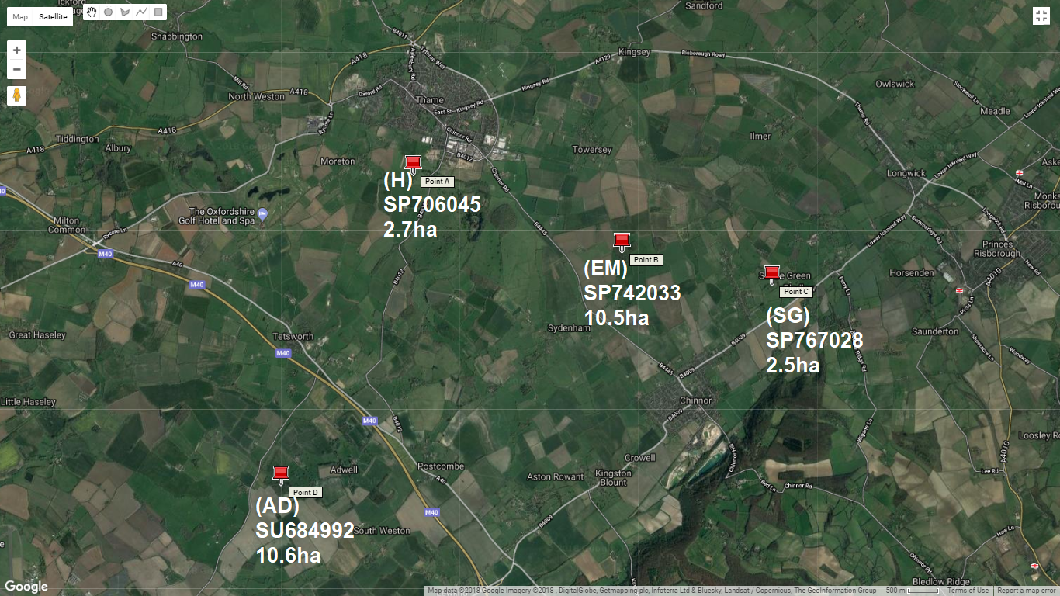
The independent variable of focus in this study was the size of each woodland (or ‘patch’), the chief interest being whether this influences species richness and abundance. Replication of study sites was necessary to provide statistically valid and empirically sound comparisons therefore four woodlands were chosen within Oxfordshire of two size classes deemed ‘small’ and ‘large’. The woodlands were chosen based on their distance from the author, distance from one another, and their approximate areas. Sites were of similar size to each other in their respective size class, in addition to being physically separated beyond the olfactory detection range of Silphids, commonly cited as two miles (Ratcliffe, 1996), to achieve site independence (Figure 1). Appendix A provides site details. The four woodland sites were of similar characteristics (lowland temperate deciduous) with land use remaining consistent outside each site to allow for valid comparisons (Appendix B).
Figure 1 – Site locations and sizes (Google, 2018)

4.3 Trap Design

4.3.1 Pitfall Construction & Installation
Silphids were recorded via the use of baited non-lethal pitfall traps (Plates 1 & 2). This method was utilised as the traps are simple in design, relatively easy to install and inexpensive to produce (Woodcock, 2005). Pitfall trapping is ubiquitous in invertebrate ecology studies as it can provide information on community structure, spatial distributions, habitat associations and population estimates (New Zealand Government, n.d.).
Pitfall traps constructed from garden pots had 130mm (top) and 90mm (base) diameters, were 120mm in height and had four circular drainage holes of 5mm, complying with the criteria in Woodcock (2005). A relatively larger circumference was chosen as it provides a higher overall catch (Wheater, Bell & Cook, 2011; Work, Buddle, Korinus & Spence, 2002). A cover was suspended above each container at a height of around 30-40mm to keep debris from accumulating (Buchholz & Hannig, 2009) and prevent rainfall from flooding the trap, potentially causing specimen death (Ratcliffe, 1996). PVC sheets (2-ply) were placed over each trap and held in place at the corners using four 30cm garden canes at each corner for stability.
Though of an epigeal nature like most other Coleoptera, Silphids are strong fliers and as such can be enticed to bait deliberately and are not as susceptible to failures or errors in trap design, e.g. the lip of the container exceeding ground level via animal or human disturbance (M. Esh, personal communication, May 19, 2018). Pitfall traps were chosen because of the author’s familiarity with the designs, the wealth of relevant and related literature, and what was deemed the natural substitution for carcass placement. Non-lethal trapping was chosen so that the ecosystem services which these beetles provide were not in any way hampered. Non-lethal trapping is commonly employed in the US where endangered Nicrophorus americanus populations are at sensitive to further depletion by lethal trapping, as in Peyton (2003) and Coyle and Larsen (1998).
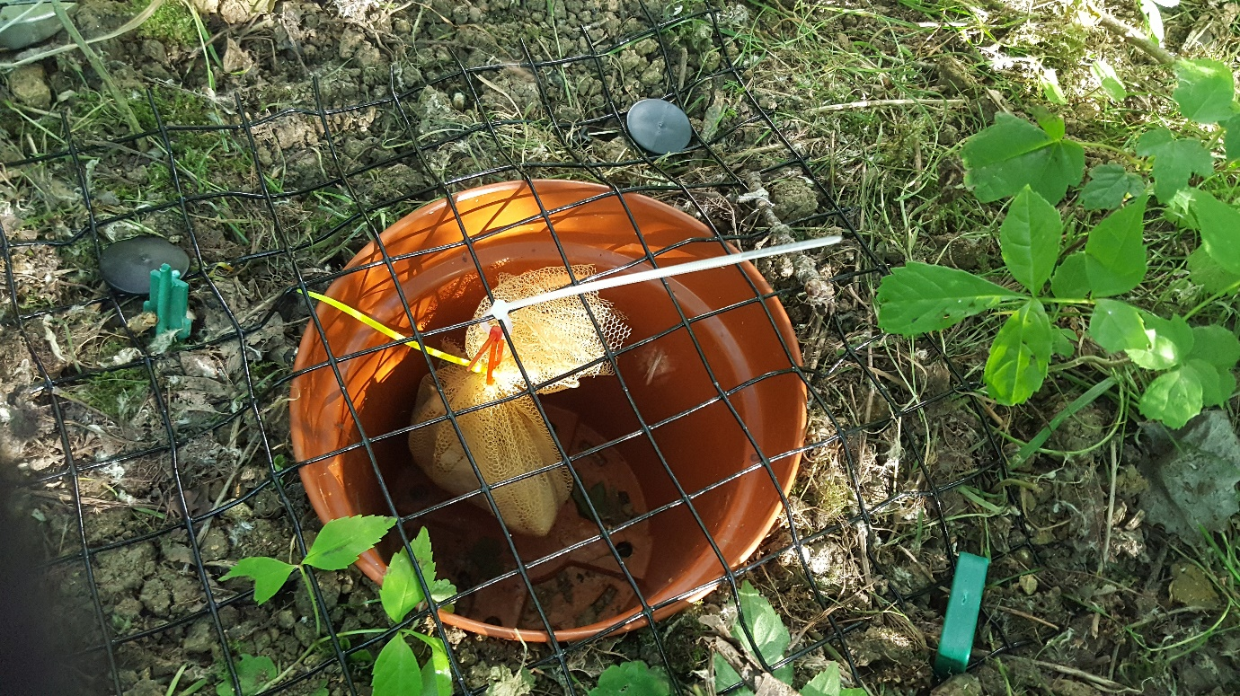
Plate 1 – Aerial view of installed pitfall trap (without cover) (Author’s own, 2018)

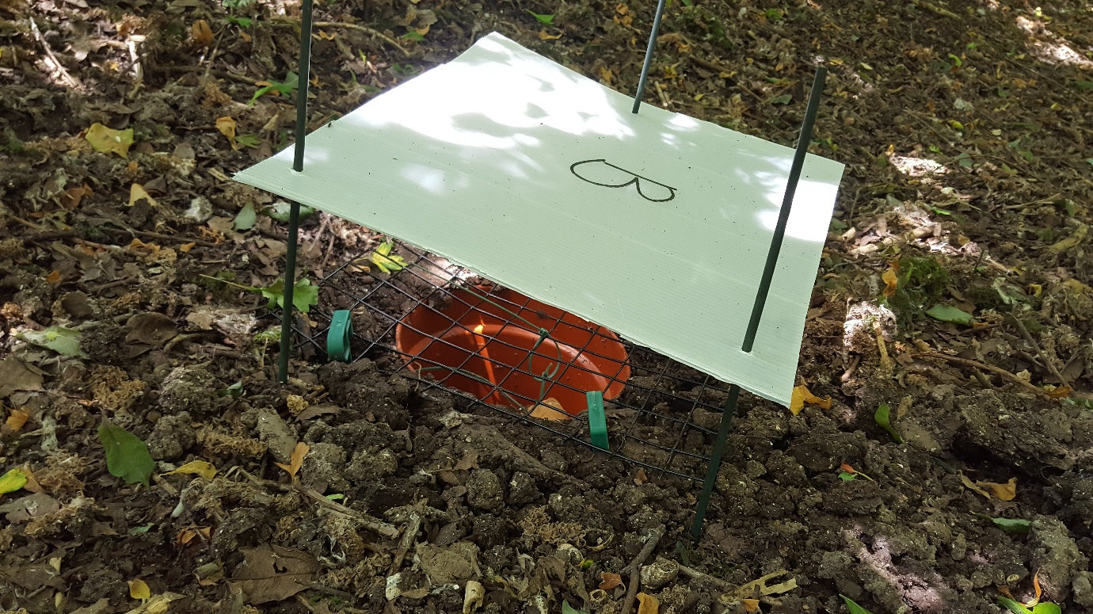
Plate 2 – Pitfall trap with secured cover (Author’s own, 2018)

4.3.2. Bait
Coyle and Larsen (1998) determined chicken to be the most effective bait, therefore this was chosen. Raw chicken wings, of which there were 16 per site per sampling week, were measured at a standard 1kg using a Salter kitchen scale (5kg max weight) and transported onto a portable Pocket Scale FEM-500g/0.1g device atop which was a plastic bowl containing the bait. Weight of baits were on average 60g. Once weighed, each bait was secured in a bag of very fine polyurethane mesh with a cable tie, another cable tie being fastened around the first for ease of attachment to the grating upon trap activation. Baits were aged for three full days in sealed plastic food storage tubs whose lids were pierced to allow for the diffusion of gas which can often build up during the process of rotting (Ratcliffe, 1996). Said tubs were placed within a large plastic storage container to reduce the smell and number of flies attracted. Baits in each woodland were renewed every seven days, the total period of aging being 10 days. The total number of baits was 64 over the four-week study period.
With the addition of bait, a means of preventing mammal disturbance was crucial. (Animal Ethics Infolink, n.d.; Ratcliffe, 1996). Fielding, Newey, Navarro and Irvine (2016) showed in their comparative study of open versus closed (caged) carcasses that Silphid abundance was highest in closed plots due the reduction of mammalian scavengers. Negation of scavenging was achieved by installing a grate with 2.5cm gap spacing over the top of each pitfall trap using six garden tent pegs staked around the frame. Five similarly sized sticks/branches were placed over the grating to limit the number of entryways.

4.4 Sampling Silphids
It was necessary to identify whether individuals reoccurred in each sampling session or if they were newly present in the area since recounting individuals would skew the data. This is a common process in mark-release-recapture (M-R-R) studies (Sutherland, 2012). In this study it was only necessary to mark every individual insofar as they would not be counted twice.
Silphids retained in the baited pitfall traps were carefully removed via the use of a Natural History Book Service (NHBS) Insect Marking Cage (75mm length, 40mm diameter) and a simple spoon or other object capable of lifting each specimen out of the pitfall traps.
In any form of insect marking, a non-invasive and unharmful approach, one that does not impede the animal’s movement, or overtly increase detection by predators, is preferred (Walker & Wineriter, 1981). Once inside the cage, the individual securely turned upon its back and held in place with the plunger, a fine dot of green NHBS marking paint was applied to the top-left section of the elytra. This paint was used as it dries quickly and is non-toxic, and therefore does not pose any threat to the specimen’s health or that of the surrounding environment (Hagler & Jackson, 2001). After marking, individuals were transported to a clear glass container of a large enough size to allow a comfortable living space as the paint dried. All recaptured individuals were released along with new specimens to allow for adequate dispersal.

4.4.1. Identification
Identification was achieved in the field using the Silphidae Recording Scheme’s Key to British Silphidae (Harvey, 2017). Photographs of each specimen were taken before painting and release for later indoor identification.

4.4.2. Numbers
According to Woodcock (2005) numbers ranging from two to 300 can be utilised depending on the design of the traps and the size of the area to be sampled. Due to scarcity of research on Silphids at the limited scale at which the author had to work, overlapping radius of trap effectiveness, and deliberate attraction to baits, density of traps was of a more experimental approach and lower per site than that of typical Coleoptera studies (M. Esh, personal communication, April 11, 2018). Four traps were installed in each of the four woodlands for a total of 16 traps.

4.4.3. Placement & Arrangement
Trap positions (Figure 2) were recorded as 10-figure grid references via the use of the phone application Grid Reference Free OS (version 3.0.0). All traps were placed in relatively open areas. An approximately central cluster arrangement was used throughout all woods for consistency and to negate any microclimatic alterations existing from the interior to the exterior edge of the woodlands (Didham, 2010; Bannerman, 1998).
Each trap was spaced roughly eight metres apart from one another in a square configuration, although natural variation in ground cover or presence of obstacles did not permit exactly consistent spacing. Appendix A provides exact locations for each pitfall trap.
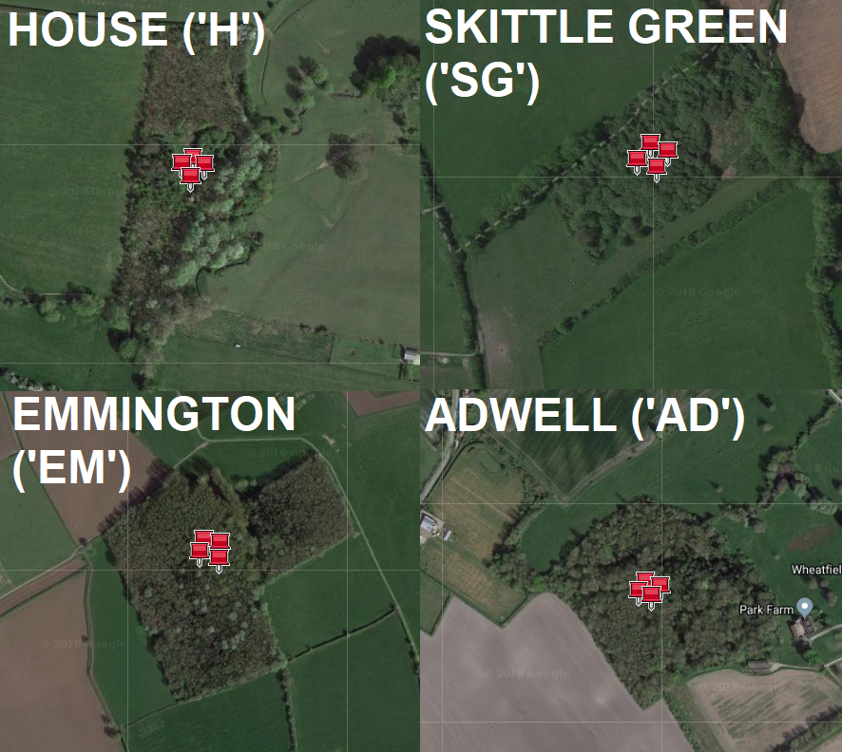
Figure 2 – Approximate placement and arrangement of pitfall traps (Google, n.d.)

4.4.4. Study Duration & Sampling Timing
Trapping took place in the summer from June to July as this is an active period according to Dekeirsschieter, Verheggen, Lognay and Haubruge (2011). A duration of four months or longer is advised, however ten to 28 days can provide useful biological information (Woodcock, 2005). This study sampled for 28 days. All traps were serviced once daily to reduce the chance of mortality from overcrowding, heat stress, flooding, and predation (Richter, Groom & Kay, 2013). Each site was visited once per day. This check took place during the evening beginning at 6pm and ending around 9pm depending on activity levels. Evening/late evening was chosen over early morning or midday due to many of the species’ nocturnal and crepuscular habits (Dekeirsschieter, Verheggen, Lognay & Haubruge, 2011).

4.5 Statistical Analysis
Raw data were recorded in a Microsoft Excel (version 1807) spreadsheet (Appendix C). Minitab 18 was used to perform the relevant statistical analyses. A non-parametric test was used as the data were skewed, being more suited to the median than the mean as the measure of central tendency, and the data is ordinal, being ranked, and therefore contained data points (outliers) which could not be removed (Minitab, 2015). As the data structure was nested and concerned multiple treatments of size upon the species richness and abundance dependant/outcome variables, two Friedman tests were utilised (Laerd Statistics, 2018). Manual post hoc testing was undertaken in Excel. Appendix D provides methodological details.

5 Results
This study captured a total of 156 individual Silphid beetles from 27th June—24th July. Overall, seven species and three genera were recorded. Figure 3 shows the total catch number within each woodland. In total, Adwell and Emmington caught 105 Silphids compared to 51 in the smaller woodlands. In the species roster Oiceoptoma thoracicum was the most numerous, whereas Thanatophilus rugosus was the least numerous (Figure 4). Figure 5 shows the average catch per visit.

Figure 3 – Overall silphid count per site

Figure 4 – Silphid species totals

Figure 5 – Average catch per visit
Friedman testing (Figures 6 & 7) detected a highly significant difference between treatment of woodland size on beetle abundance (χ²(3) = 18.16, p < 0.001). Friedman testing was utilised for beetle species richness also, with a significant difference detected (χ²(3) = 17.67, p = 0.001). These results indicated a statistical disparity between two or more summed rank values in each test therefore two post hoc pairwise comparisons were carried out. Post hoc analysis showed that Skittle Green differed from the two larger sites, Adwell and Emmington.

Figure 6 – Post hoc analysis for silphid abundance

Figure 7 – Post hoc analysis for silphid species richness
Tables 1 & 2 provide summary statistics used in post hoc analysis, with Skittle Green providing the lowest median and sum of ranks values. Minitab test printouts are provided in Appendix D.
Table 1 – Beetle abundance output
SITE | N | Median | Sum of Ranks
Adwell | 28 | 1.25 | 82.5
Emmington | 28 | 1.50 | 79.5
House | 28 | 1.00 | 68.5
Skittle Green | 28 | 0.25 | 49.5
Overall | 112 | 1.00

Table 2 – Beetle species richness output
SITE | N | Median | Sum of Ranks
Adwell | 28 | 1.00 | 81.0
Emmington | 28 | 1.00 | 78.0
House | 28 | 1.00 | 70.5
Skittle Green | 28 | 0.00 | 50.5
Overall | 112 | 0.75

6 Discussion

6.1 Results & Theory
This study sought to determine whether woodland size had an impact on Silphid abundance and species richness through a repeated-measures design. Results show that a greater proportion of Silphids were caught within the two large size classes of woodlands. Means for each species were relatively low due to the family’s limited species diversity and low capture rate at each site, resulting in a limited dataset. There are intrinsic weaknesses in the analytical methods employed. Firstly, as the data were found to be non-normal therefore there is inherently less statistical power than those data conforming to a parametric distribution (Dytham, 2011). The chief issue is that reliability is compromised. As the data produced uses the median as its central measure, the analysis may be said to be highly generalized and does not consider every element in the dataset (Agarwal, 2006). Furthermore, the Friedman test assesses only the rank information of the data not the median values themselves, therefore it is possible to produce divergences between the mean ranks and the original medians such that significance is falsely achieved (Pett, 1997).
Post hoc testing showed that Skittle Green (SG) was significantly different from Adwell and Emmington, therefore the null hypotheses that there will be no difference in species richness and abundance between large and small sites are rejected. However, as the number of individuals caught often matched or only slightly exceeded the number of species at each visit overall, resulting in identical post hoc analyses, it was not possible to infer any statistical phenomena other than that already described. One should expect the site named House to show statistical difference if there is some law at work, but it was exactly intermediate to the others, showing no differences to any site. According to Gardener (n.d.) post hoc analysis for Friedman results is highly limited and is not a sensible procedure in this context. Larger samples may have been required to detect a difference.
The defining concern is that the project does not address crucial biotic and abiotic factors, such as the presence of scavengers, changes in temperature, soil characteristics, or the shape and structure of the woodlands. Methodologies were not utilised to measure these variables directly, e.g. carcass interment rates, the recording of vertebrate sightings per day or application of more specialised woodland metrics. Furthermore, some of the specifics of Silphid ecology had little bearing in the context of the design or were not properly emulated. For example, the weight preferences of carcasses preferred by the subfamilies in natural situations was not important since the baits were not interred or used in any way except to attract. The standard weight of 60g was chosen only to ensure consistency and reliability in respect to that element of the design, namely the potency of the odour produced by each chicken wing. Another example is found in the non-randomness of the design. Whereas Silphids are likely to find carcasses at random, the situation of the traps did not emulate this as they were located always in the interior, therefore the data may be susceptible to bias and misrepresentation (Hill, Fasham, Tucker, Shewry & Shaw, 2005). The results may be considered to show little else than what may already be expected by simple biological occurrences, namely that larger habitats are likely to contain more species than small habitats and cannot be said to be indicative of any other theoretical cause other than that just stated. Overall, though the sole focus was on woodland size, it is acknowledged that many other factors may have influenced the results, therefore these must be discussed insofar as they relate to the constructed hypotheses.
The majority of Silphids are generalists and will take carcasses in many habitats, even those exhibiting preferences. There was no way to account for the method of traversal by which species reached the baited traps; some individuals may have crossed several different and varied habitats whereas others will have originated from within the wooded sites themselves. This puts into question the validity of the hypotheses, therefore only those species which may be considered woodland inhabitants will be discussed. Although there will be natural deviation from the categories, Oiceoptoma thoracicum, Nicrophorus humator and N. vespilloides, may fit this description (Dekeirsschieter, Verheggen, Lognay & Haubruge, 2011). O. thoracicum’s preference for closed vegetation, preferring even in habitat as open as heathland the dense ericaceous vegetation to bare ground (Guy, n.d.), perhaps renders it vulnerable to exposed matrix areas. However, the species was the most abundant in this study and is not as dependant on carrion for reproduction as it belongs to the Silphinae, therefore it may not be a conservation priority. N. humator is largely found in hardwood forests, and as these hold the greatest biodiversity and likely support larger stores of carrion resources, here the species may be most at risk (von hoermann et al., 2015), as might N. vespilloides (Pascoal & Kilner, 2017).
Theory suggests that size is indeed the most important factor (Trumbo & Bloch, 2000; Wolf & Gibbs, 2004, Devault et al, 2011; Sigiura et al., 2013), and it may be said to influence all others, for example the amount of edge and landscape connections. Although this study did not examine in detail the physical characteristics of each woodland, some general properties of the four may be postulated. One structural consideration is that of the woods’ density or accessibility (Appendix B). As in Ratcliffe (1996), traps within denser woodlands may be more difficult to navigate in flight. Though each woodland was sought out for their similar physiognomies, as well as sizes, SG was somewhat denser. This may account for SG catching the least number of Silphids, all other factors being equal. SG was not the first choice regarding selection of the Small 2 category of woodland, but the first was not attainable. The two large woodlands were of a more natural composition and situation, having significant points of entry. It is the author’s opinion that density conditions should not overtly impede Silphids to any significant degree due to the strong evolutionary olfactory adaptations present and the need for such crucial resources. This is evidenced by a preliminary experiment undertaken by the author in spring which found N. humator specimens within a makeshift and highly secluded pitfall design.
Exterior rather than interior factors may be more important. The studies discussed throughout this report have generally posited that lower breeding success, abundance and species richness occurs at edges. Emmington appears to have the greatest edge proportion (Figure 2), counteracting the benefit of its size with increased scavenger activity, however the lower Silphid count compared to Adwell cannot be attributed to this alone (once more considering that this study does not directly measure these variables). Surrounding connections must also determine the assemblage. The importance of network variables will weigh differently on specific taxonomic groups and in the metanalysis provided in Appleton et al. (2015), invertebrates of temperate woodlands are influenced more by the amount of surrounding woodland than all other factors. Of the large sites, it is apparent that Adwell is overall the most contiguous and connected with linear corridors, whereas Emmington, though relatively large, is isolated via various field systems. The small sites are similar in shape although again SG is the more inaccessible of the two. Figure 11 (Appendix B) shows the relative sparsity of woodland in the north-west compared to the south-east. Figures 12 – 15 (Appendix B) show the proximity to statutory sites of nature conservation interest within the common flight range of two miles. Though impossible to determine in this study, interfaces between the wooded region around Chinnor and Ashton Rowant, and the four sites may be important. SG’s limited size and inaccessibility in closed-off farmland and its situation in the village of Henton may nullify benefits of proximity to this densely wooded landscape.
The predominant setting was arable. As this study did not examine the character of these fields, only generic inferences can be put forward. Mesopredators such as foxes, stoats and weasels, in addition to scavenging birds, for example the carrion crow, are prevalent in disturbed anthropogenic landscapes, therefore competition with Silphidae is greater here than in natural unmodified settings (DeVault, Olson, Beasley & Rhodes, 2011). Furthermore, the legislative removal of dead livestock to reduce disease transmission (Fielding, Newey, van der Wal & Irvine, 2013) must result in an impoverished carrion pool for both vertebrates and insects.
As for dispersal through the landscape, though all but one pairing of the study sites may be considered independent from one another, one must consider that these beetles are a distinctly mobile group, and that this independence may not have been enough for each woodland to represent an island in and of itself. However, the autho could not determine from the literature how exact Silphid olfactory perception or strength is, it is unlikely that an individual beetle could travel two miles to another of the study sites when myriad obstacles stand between each site, including fresh carcasses at other locations. Furthermore, the recaptured individuals, many of which were Oiceoptoma thoracicum, suggests that some Silphids stay somewhat tethered to areas likely to harbour resources. This is borne out by Jakubec and Růžička (2015) who state that though most Silphids are good fliers they prefer to remain close to their original locations, in addition to Pascoal and Kilner (2017) who postulated the detrimental effects of potential matrix barriers on N. humator.

6.2 Sources of Error
Though the design of this study was adequate in its use of pitfall traps, a common Coleopteran sampling method, and followed closely the literature for bait preparation and protection, certain aspects of Silphid ecology, in addition to practical difficulties, rendered the study susceptible to many sources of error.
Gaps in the grates or inappropriately sized mesh choice may have allowed certain individuals to escape. Although the gap size chosen was such that most species could not escape in flight, many smaller species such as Thanatophilus rugosus may have easily escaped. This is something which must be accounted for when viewing the data produced for this report. The remedial action of placing sticks across the grating to limit the chance of escape whilst still allowing entry may have helped, but it is noted that this could not be easily standardised and is susceptible to disturbance. However, no disturbance to any trap or trap element occurred due to the relative seclusion of the sites.
The author considered alternative trapping methods, such as ground-based inverted bottle traps and hanging bottle traps. As for the former, this was not common in the literature, and in the latter the arboreal situation was deemed inappropriate or unrealistic since carcasses are generally found at ground level. In both cases the relatively smaller apertures of entry may have vastly reduced species. In hindsight, larger sample sizes may have been too difficult to process had either of these techniques worked. Although these may constitute a fair of set of arguments there can be no way of interpreting how many species were lost between sampling sessions with the method employed in the current study, therefore the sample size could have been much larger if another trap design was implemented.
There was a considerable dilemma in the choice between live or lethal trapping. As live-trapping was ultimately used it may have resulted in the loss of many individuals, as discussed, but it was also strenuous and time consuming. The preparation of the bait, setting of the traps, and the catching and marking of every individual all contributed to a level of fatigue near the end of the study which could have been entirely negated using lethal traps. Were lethal traps to be employed the effort would have been much reduced and the amount of data accrued would be much larger. The bulk of the procedure would have shifted from a practical pursuit to one based solely on identification. One must ask whether the justification of safeguarding the ecosystem services provided by Silphids was detrimental to the production of a scientifically rigorous study.
It is likely that non-target species, such as Carabids and Histerids (among other unidentified beetles), several of which were found over the study period, may have limited the success of traps due to interference. Detrimental activity from predatory Coleopterans was a concern throughout the study, the presence of which the author could not at the time guard against except to remove them. However, these non-target species were not abundant at most sampling sessions.
Another problematic area was specimen marking. The data may be exaggerated if the paint was easily removed and reoccurring individuals were counted. This error may not be as devastating to the hypotheses since the sampling took place over an exceedingly warm and dry summer and the marks on recurring individuals were generally high quality. This suggests that the paint applications were unlikely to fade. Even marks which were of lesser quality retained at least some recognisable signature and could be easily discounted from the totals of the day.
As sampling was restricted to an evening or late evening period, again roughly 6-9pm, this may not have been sufficiently late in summer considering many Silphid species’ crepuscular or nocturnal habits.
Species misidentification was a possibility but not likely due the conspicuous morphology of the few main genera recorded.

6.3 Study Relevance & Limitations
Although the data may be considered robust in its to its nested format (multiple visits) in addition to the twice-replicated woodland class sizes and independence of sites, the limited scope regarding woodland site selection, relatively low overall species and abundance numbers due to an impractical and time consuming live-trapping methodology, and weaknesses of the statistical analysis employed, means that this study is not likely to influence management at the scale necessary to affect change in fragmented areas. Another limitation is that the larger woodlands were by restrictions of travel and time not sufficiently large to be meaningfully different. In all, this study concurs with the literature, but only insofar as simple abundance and richness measures are concerned. Furthermore, according to Zuiderna, Sayer and Dijkman (1996), it does not add to the literature as many studies already focus on fragments <10ha and thus cannot be extrapolated to larger protected areas which are the focus of much conservation work and concern. It must also be noted that whilst fragmentation may impact these beetles, many species are common throughout the UK, especially those preferring woodlands (Figures 13 – 15, Appendix B). UK Silphidae are not experiencing severe declines.

6.4 Further Study
Regarding modifications to the current study design, lethal trapping would have yielded more extensive data, therefore this is advised. Woodland size was determined somewhat arbitrarily due to the study’s being limited to the area in which the author lives and the limited information or subjectivity as to what is deemed large, medium, or small. Pavuk and Wadsworth (2013) classified >100ha as large and <20ha as small. Some sources consider <10 ha to be a small woodland, however (Small Woods, 2018). It may be beneficial to set traps in a larger number of woodlands and of vastly differing sizes, for example urban fragments compared to the heavily wooded region of the Chilterns.
There exist three possible investigative branches for projects outside of or complimentary with pitfall trapping. With adequate time it may be beneficial to carry out an interment study after the fashion of Sugiura, Tanaka, Taki and Kanzaki (2013), Wolf and Gibbs (2004), and Trumbo and Bloch (2000) to gain an understanding of the physical and direct impact of the ecosystem services provided in each woodland. There may be limitations in the quantitative potential of this method, but its presence would be merely a supplementary one to reinforce data gathered from pitfall traps. If the resource used by Silphids can be shown continually to decrease (removed by scavengers), this may provide a clearer incentive for land managers or policy makers to combat fragmentation than measures of abundance or richness alone.
Secondly, the focus should be placed on a more specialist woodland species such as Nicrophorus humator so that potential effects can be made more reliable and discernible, with respect to von hoermann et al. (2015). This has the benefit that the study would take place within a relatively closed system where it is known that individuals are not likely to migrate from fields to woodland between each sampling session, for example, as was the case in the current study. An indicator species for this family may increase conservation awareness. Mark-Release-Recapture could also be utilised so that dispersal is accounted for and elucidate more in-depth population analysis.
The third branch concerns abiotic factors. Recording continuous numerical data for temperature or in some way categorising canopy density or soils may be useful to assess the interplay between Silphids and their environment.

7 Conclusion
This study identified a significant difference in the abundance and species richness of Silphids between one small woodland compared to two large woodlands. However, the data utilised to produce these results are not comprehensive, and due to defining issues such as habitat non-specificity and the inability to trace individual traversals, findings are not likely to be biologically important or may be the result of a complex interplay of factors which were not examined methodologically.
With these beetles, issues of fragmentation are not clear-cut and there appear to be several ambiguities regarding the way in which different biotic and abiotic influences may have acted upon the results, or in what way Silphids might respond to loss of woodland. Generally, agricultural intensification and development of the surrounding countryside may lead to fewer opportunities to find and inter carrion, but there may also be an increase in generalist vertebrate carcasses adding to the carrion pool through increased association with human environments. Silphids appear to exhibit great mobility yet may be tied to resource-rich woodlands either because of matrix barriers or unwillingness to leave good habitat, another example of ambiguity.
The named woodland species likely require semi-natural woodlands of large enough size to provide the spatio-temporal heterogeneity for increased rates of securement of carrion resources and the concealment of carcasses from scavengers. Thus, retention of undisturbed and ancient woodlands is important in a fragmented landscape. Connections with the heavily wooded south-east of the county may be ideal.

References
Agarwal, B. (2006). Basic statistics (4th ed.). London: New Age International (P) Limited, Publishers.
Andresen, E. (2003). Effect of forest fragmentation on dung beetle communities and functional consequences for plant regeneration. Ecography, 26(1), 87-97. doi: 10.1034/j.1600-0587.2003.03362.x
Anderson, R. (1982). Resource partitioning in the carrion beetle (Coleoptera:Silphidae) fauna of southern Ontario: ecological and evolutionary considerations. Canadian Journal of Zoology, 60(6), 1314-1325. doi: 10.1139/z82-178
Animal Ethics Infolink. (n.d.) Use of pitfall traps. Retrieved from https://www.animalethics.org.au/policies-and-guidelines/wildlife-research/pitfall-traps
Appleton, D., Crosher, I., Duffield, S., Erian, J., Hall, J., & Macgregor, N. et al. (2015). Habitat Fragmentation Theme Plan [Ebook] (1st ed.). Natural England. Retrieved from http://publications.naturalengland.org.uk/file/4889011434815488
Bannerman, S. (1998). Biodiversity and Interior Habitats: The Need to Minimize Edge Effects [Ebook] (1st ed.). Victoria: Ministry of Forests Research Program. Retrieved from https://www.for.gov.bc.ca/hfd/pubs/docs/en/en21.pdf
Barton, P., Cunningham, S., Lindenmayer, D., & Manning, A. (2012). The role of carrion in maintaining biodiversity and ecological processes in terrestrial ecosystems. Oecologia, 171(4), 761-772. doi: 10.1007/s00442-012-2460-3
Benbow, M., Tomberlin, J., & Tarone, A. (2016). Carrion ecology, evolution, and their applications. Boca Raton: CRC Press - Taylor & Francis Group.
Beutel, R., Leschen, R., & Lawrence, J. (2016). Coleoptera, Beetles. Morphology and Systematics (2nd ed.). Berlin: De Gruyter.
Brunelle, & Catling. (2011). COSEWIC Assessment and Status Report on the American Burying Beetle Nicrophorus americanus in Canada [Ebook] (1st ed.). Ottawa: Canadian Wildlife Service. Retrieved from http://publications.gc.ca/collections/collection_2012/ec/CW69-14-640-2012-eng.pdf
Buchholz, S., & Hannig, K. (2009). Do covers influence the capture efficiency of pitfall traps?. European Journal of Entomology, 106(4), 667-671. http://dx.doi.org/10.14411/eje.2009.083
Cambefort, Y., & Hanski, I. (1991). Dung Beetle Ecology (1st ed.). Princeton: Princeton University Press.
Capinera, J. (2008). Encyclopedia of entomology. [Berlin]: Springer.
Centre for Disease Control and Prevention. (2015). Prevention. Retrieved from https://www.cdc.gov/salmonella/general/prevention.html
Coyle, D., & Larsen, K. (1998). Carrion Beetles (Coleoptera: Silphidae) of Northeastern Iowa: A Comparison of Baits for Sampling. Journal of The Iowa Academy of Science, 105(4), 161-164.
Dekeirsschieter, J., Verheggen, F., & Haubruge, E. (2011). Large carrion beetles (Coleoptera, Silphidae) in Western Europe: a review. Biotechnology, Agronomy, Society and Environment, 15(3), 435-447.
DeVault, T., Olson, Z., Beasley, J., & Rhodes, O. (2011). Mesopredators dominate competition for carrion in an agricultural landscape. Basic and Applied Ecology, 12(3), 268-274. doi: 10.1016/j.baae.2011.02.008
Didham, R. (2010). Ecological Consequences of Habitat Fragmentation. Encyclopaedia of Life Sciences.
Dyer, N., & Price, D. (2013). Notes on the Diversity and Foraging Height of Carrion Beetles (Coleoptera: Silphidae) of the Nassawango Creek Preserve, Maryland, USA. The Coleopterists Bulletin, 67(3), 397-400. doi: 10.1649/0010-065x-67.3.397
Dytham, C. (2011). Choosing and using statistics (3rd ed.). Hoboken, NJ: Wiley-Blackwell.
Duthie, A. (2013). Species interactions in ephemeral patch systems: spatial, temporal, and spatio-temporal influences (Ph.D.). Iowa State University.
Fielding, D., Newey, S., Navarro, C., & Irvine, J. (2016). Biodiversity and Upland Management [Ebook] (1st ed.). James Hutton Institute. Retrieved from https://www.hutton.ac.uk/sites/default/files/files/publications/Upland%20booklet_reduced_size_web.pdf
Fielding, D., Newey, S., van der Wal, R., & Irvine, R. (2013). Carcass Provisioning to Support Scavengers: Evaluating a Controversial Nature Conservation Practice. AMBIO, 43(6), 810-819. doi: 10.1007/s13280-013-0469-4
Fusco, N., Zhao, A., & Munshi-South, J. (2017). Urban forests sustain diverse carrion beetle assemblages in the New York City metropolitan area. Peerj, 5, e3088. http://dx.doi.org/10.7717/peerj.3088
Gardener, M. (n.d.). Statistics. http://www.dataanalytics.org.uk. Retrieved 24 February 2019, from http://www.dataanalytics.org.uk/Data%20Analysis/Statistics/choosing-your-stats-test.htm#ANOVA
Gaublomme, E., Hendrickx, F., Dhuyvetter, H., & Desender, K. (2008). The effects of forest patch size and matrix type on changes in carabid beetle assemblages in an urbanized landscape. Biological Conservation, 141(10), 2585-2596. doi: 10.1016/j.biocon.2008.07.022
Gennard, D. (2007). Forensic entomology (1st ed.). Hoboken, N.J.: Wiley.
Gibbs, J., & Stanton, E. (2001). Habitat Fragmentation and Arthropod Community Change: Carrion Beetles, Phoretic Mites, and Flies. Ecological Applications, 11(1), 79. http://dx.doi.org/10.2307/3061057
Google. (n.d.). Approximate placement and arrangement of pitfall traps [Image].
Google. (2018). Site locations and sizes [Image].
Guy, R. Utilisation of carrion by Silphidae (Coleoptera) on lowland heathland, England. (MSc). Staffordshire University.
Haddad, N., Brudvig, L., Clobert, J., Davies, K., Gonzalez, A., & Holt, R. et al. (2015). Habitat fragmentation and its lasting impact on Earth's ecosystems. Science Advances, 1(2). doi: 10.1126/sciadv.1500052
Hagler, J., & Jackson, C. (2001). METHODS FOR MARKING INSECTS: Current Techniques and Future Prospects. Annual Review of Entomology, 46(1), 511-543. http://dx.doi.org/10.1146/annurev.ento.46.1.511
Harvey, M. (2017). New keys available for Silphidae (burying beetles). Retrieved from http://www.coleoptera.org.uk/silphidae/news/new-keys-available-silphidae-burying-beetles
Hill, Fasham, Tucker, Shewry, & Shaw. (2005). Handbook of Biodiversity Methods: Survey, Evaluation and Monitoring (1st ed.). Cambridge: Cambridge University Press.
Jakubec, P., & Růžička, J. (2015). Is the type of soil an important factor determining the local abundance of carrion beetles (Coleoptera: Silphidae)?. European Journal of Entomology, 112(4), 747-754.
Kalinová, B., Podskalská, H., Růžička, J., & Hoskovec, M. (2009). Irresistible bouquet of death—how are burying beetles (Coleoptera: Silphidae: Nicrophorus) attracted by carcasses. Naturwissenschaften, 96(8), 889-899. doi: 10.1007/s00114-009-0545-6
Kocarek, P. (2002). Diel activity patterns of carrion-visiting Coleoptera studied by time-sorting pitfall traps. Biologia Bratislava, 57(2), 199-211.
Laerd Statistics. (2018) Friedman Test in SPSS Statistics Retrieved from https://statistics.laerd.com/spss-tutorials/friedman-test-using-spss-statistics.php
Legros, D., & Beresford, D. (2010). Aerial foraging and sexual dimorphism in burying beetles (Silphidae: Coleoptera) in a central Ontario forest. Journal of The Entomological Society of Ontario, 141, 3-10.
Lindenmayer, D., Bennett, A., & Hobbs, R. (2010). Temperate woodland conservation and management. Melbourne: CSIRO publ.
Lindenmayer, D., & Fischer, J. (2013). Habitat fragmentation and landscape change (1st ed.). [United States]: Island Press.
Lomolino, M., & Creighton, J. (1996). Habitat selection, breeding success and conservation of the endangered American burying beetle Nicrophorus americanus. Biological Conservation, 77(2-3), 235-241. doi: 10.1016/0006-3207(96)00003-1
Minitab (2015). Choosing Between a Nonparametric Test and a Parametric Test. Retrieved from http://blog.minitab.com/blog/adventures-in-statistics-2/choosing-between-a-nonparametric-test-and-a-parametric-test
Mondor, E., Tremblay, M., Tomberlin, J., Benbow, E., Tarone, A., & Crippen, T. (2012). The Ecology of Carrion Decomposition. Nature Education Knowledge, 3(10), 21.
Natural England. (2018). Adwell/Large 2 designations [Image].
Natural England. (2018). Emmington/Large 1 designations [Image].
Natural England. (2018). House/Small 1 designations [Image].
Natural England. (2018). Skittle Green/Small 2 designations [Image].
Natural England. (2019). Site surroundings and woodland extent [Image].
NBN Atlas. (n.d.). Nicrophorus humator records [Image]. Retrieved from https://records.nbnatlas.org/occurrences/search?q=lsid:NBNSYS0000023036#tab_mapView
NBN Atlas. (n.d.). Nicrophorus vespilloides records [Image]. Retrieved from https://records.nbnatlas.org/occurrences/search?q=lsid:NBNSYS0000023040#tab_mapView
NBN Atlas. (n.d.). Oiceoptoma thoracicum records [Image]. Retrieved from https://records.nbnatlas.org/occurrences/search?q=lsid:NBNSYS0000023046#tab_mapView
New, T. (2010). Beetles in conservation (1st ed.). Hoboken, NJ: Wiley-Blackwell.
New Zealand Government (n.d.). Invertebrates: pitfall trapping (1st ed.). Retrieved from http://www.doc.govt.nz/Documents/science-and-technical/inventory-monitoring/im-toolbox-invertebrates-pitfall-trapping.pdf
Ninan, K. (2009). Conserving and Valuing Ecosystem Services and Biodiversity (1st ed.). Abingdon: Earthscan.
Pascoal, S., & Kilner, R. (2017). Development and application of 14 microsatellite markers in the burying beetle Nicrophorus vespilloides reveals population genetic differentiation at local spatial scales. Peerj, 5, e3278. doi: 10.7717/peerj.3278
Pavuk, D., & Wadsworth, A. (2013). Longhorned beetle (Coleoptera: Cerambycidae) diversity in a fragmented temperate forest landscape. F1000research, 1(25). doi: 10.12688/f1000research.1-25.v1
Peyton, M. (2003). Range and Population Size of the American Burying Beetle (Coleoptera: Silphidae) in the Dissected Hills of South-Central Nebraska. Great Plains Research, 13(1), 127-138.
Pett, M. (1997). Nonparametric statistics in health care research (1st ed.). Thousand Oaks: SAGE.
Ratcliffe, B. (1996). The carrion beetles (Coleoptera, Silphidae) of Nebraska. Lincoln (Neb.): University of Nebraska State Museum.
Richter, V., Groom, C., & Kay, R. (2013). Dry Pitfall Trapping for Vertebrates and Invertebrates [Ebook] (1st ed.). Department of Parks and Wildlife. Retrieved from https://www.dpaw.wa.gov.au/images/documents/plants-animals/monitoring/sop/sop09.3_pitfalltraps_v1.1.pdf
Riutta, T., Slade, E., Morecroft, M., Bebber, D., & Malhi, Y. (2014). Living on the edge: quantifying the structure of a fragmented forest landscape in England. Landscape Ecology, 29(6), 949-961. doi: 10.1007/s10980-014-0025-z
Ružicka, J. (1994). Seasonal activity and habitat associations of Silphidae and Leiodidae: Cholevinae (Coleoptera) in central Bohemia. Acta Societas Zoologicae Bohemicae, 58, 67-78.
Schowalter, T. (2016). Insect Ecology: An Ecosystem Approach. Elsevier Science & Technology Books.
Scott, M. (1998). The Ecology and Behavior of Burying Beetles. Annual Review of Entomology, 43(1), 595-618.
Shubeck, P. (1983). Habitat Preferences of Carrion Beetles in the Great Swamp National Wildlife Refuge, New Jersey (Coleoptera: Silphidae, Dermestidae, Nitidulidae, Histeridae, Scarabaeidae). Journal of The New York Entomological Society, 9(4), 333-341.
Small Woods (2018). Owning a woodland. Retrieved from http://www.smallwoods.org.uk/information/owning-woodland/
Smith, K. (1986). A Manual of Forensic Entomology (1st ed.). London: British Museum (Natural History).
Sugiura, S., Tanaka, R., Taki, H., & Kanzaki, N. (2013). Differential responses of scavenging arthropods and vertebrates to forest loss maintain ecosystem function in a heterogeneous landscape. Biological Conservation, 159, 206-213. doi: 10.1016/j.biocon.2012.11.003
Sutherland, W. (2012). Ecological census techniques. Cambridge [u.a.]: Cambridge Univ. Press.
Trumbo, S., & Bloch, P. (2000). Habitat Fragmentation and Burying Beetle Abundance and Success. Journal of Insect Conservation, 4(4), 245-252.
Ulrich, W., Zalewski, M., & Komosiński, K. (2007). Diversity of carrion visiting beetles at rural and urban sites. Community Ecology, 8(2), 171-181. http://dx.doi.org/10.1556/comec.8.2007.2.4
von Hoermann, C., Jauch, D., Kubotsch, C., Reichel-Jung, K., Steiger, S., & Ayasse, M. (2018). Effects of abiotic environmental factors and land use on the diversity of carrion-visiting silphid beetles (Coleoptera: Silphidae): A large scale carrion study. PLOS ONE, 13(5), e0196839. doi: 10.1371/journal.pone.0196839
Walker, T., & Wineriter, S. (1981). Marking Techniques for Recognizing Individual Insects. The Florida Entomologist, 64(1), 18. http://dx.doi.org/10.2307/3494598
Wilson, M., Chen, X., Corlett, R., Didham, R., Ding, P., & Holt, R. et al. (2016). Habitat fragmentation and biodiversity conservation: key findings and future challenges. Landscape Ecology, 31(2), 219-227. doi: 10.1007/s10980-015-0312-3
Wheater, C., Cook, P., & Bell, J. (2011). Practical Field Ecology (1st ed.). Hoboken, N.J.: Wiley-Blackwell.
Wolf, J., & Gibbs, J. (2004). Silphids in urban forests: Diversity and function. Urban Ecosystems, 7(4), 371-384. http://dx.doi.org/10.1007/s11252-005-6836-6
Woodcock, B. (2005). Insect Sampling in Forest Ecosystems (1st ed.). Blackwell Publishing.
Woodland Trust. (n.d.). Woodland biodiversity: Expanding our horizons [Ebook] (1st ed.). Retrieved from https://www.researchgate.net/profile/Richard_Smithers/publication/230853609_Woodland_Biodiversity_Expanding_our_horizons/links/09e4150c771b0ec95d000000/Woodland-Biodiversity-Expanding-our-horizons.pdf
Work, T., Buddle, C., Korinus, L., & Spence, J. (2002). Pitfall Trap Size and Capture of Three Taxa of Litter-Dwelling Arthropods: Implications for Biodiversity Studies. Environmental Entomology, 31(3), 438-448. doi: 10.1603/0046-225x-31.3.438
Zaiontz, C. (2019). Friedman Test Post-hoc Analysis. Retrieved from http://www.real-statistics.com/anova-repeated-measures/friedman-test/friedman-test-post-hoc-analysis/
Zuidema, P., Sayer, J., & Dijkman, W. (1996). Forest fragmentation and biodiversity: the case for intermediate-sized conservation areas. Environmental Conservation, 23(04), 290. doi: 10.1017/s037689290003914x

Appendices

[A] Site and Trap Details
Table 3 – Distance matrix (Miles)
 | House (H) | Emmington (EM) | Skittle Green (SG) | Adwell (AD)
House (H) | - | 2.438 | 3.945 | 3.549
Emmington (EM) | 2.348 | - | 1.607 | 4.353
Skittle Green (SG) | 3.945 | 1.607 | - | 5.582
Adwell (AD) | 3.549 | 4.353 | 5.582 | -
All site distances exceeded two miles except that of ‘Emmington’ to ‘Skittle Green’ which was approximately 1.6 miles.
Table 4 – Pitfall trap positions
Location | Description | Grid Reference | Postcode (Nearest)
H | Trap 1 | SP 7066404560 | OX9 3PJ
H | Trap 2 | SP 7065504555 | OX9 3PJ
H | Trap 3 | SP 7067404555 | OX9 3PJ
H | Trap 4 | SP 7066304544 | OX9 3PJ
EM | Trap 1 | SP 7425203338 | OX39 4AA
EM | Trap 2 | SP 7428003334 | OX39 4AA
EM | Trap 3 | SP 7424403317 | OX39 4AA
EM | Trap 4 | SP 7427903305 | OX39 4AA
SG | Trap 1 | SP 7678302797 | HP27 9PJ
SG | Trap 2 | SP 7677102783 | HP27 9PJ
SG | Trap 3 | SP 7679802790 | HP27 9PJ
SG | Trap 4 | SP 7678802777 | HP27 9PJ
AD | Trap 1 | SU 6845599282 | OX9 7ET
AD | Trap 2 | SU 6848199274 | OX9 7ET
AD | Trap 3 | SU 6846699258 | OX9 7ET
AD | Trap 4 | SU 6844499264 | OX9 7ET

[B] Woodland/Site Photography & Other Information
The plates here presented show some of the features which were pertinent to this report’s discussion. *
HOUSE/SMALL 1
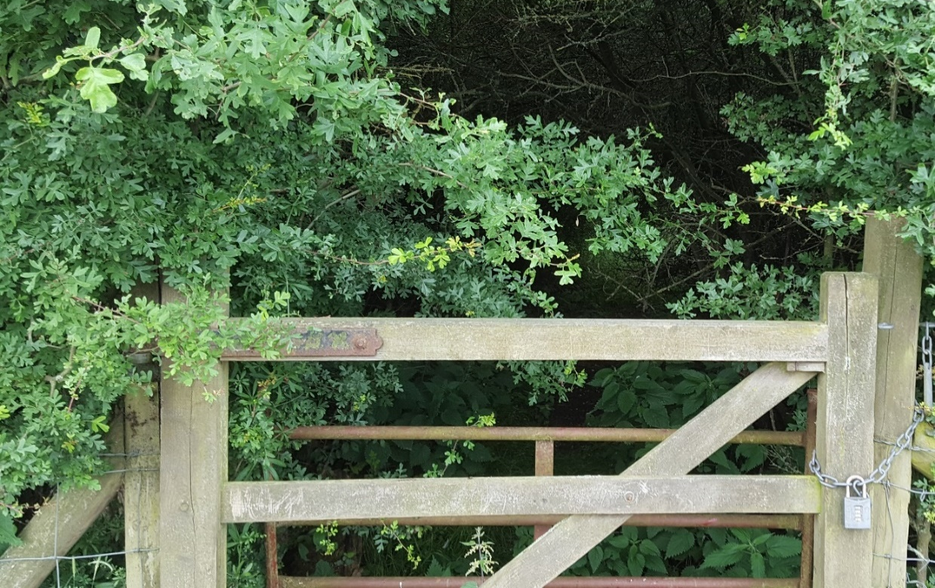
Plate 3 – Inaccessible perimeter of ‘House’ woodland (Author’s own, 2018)
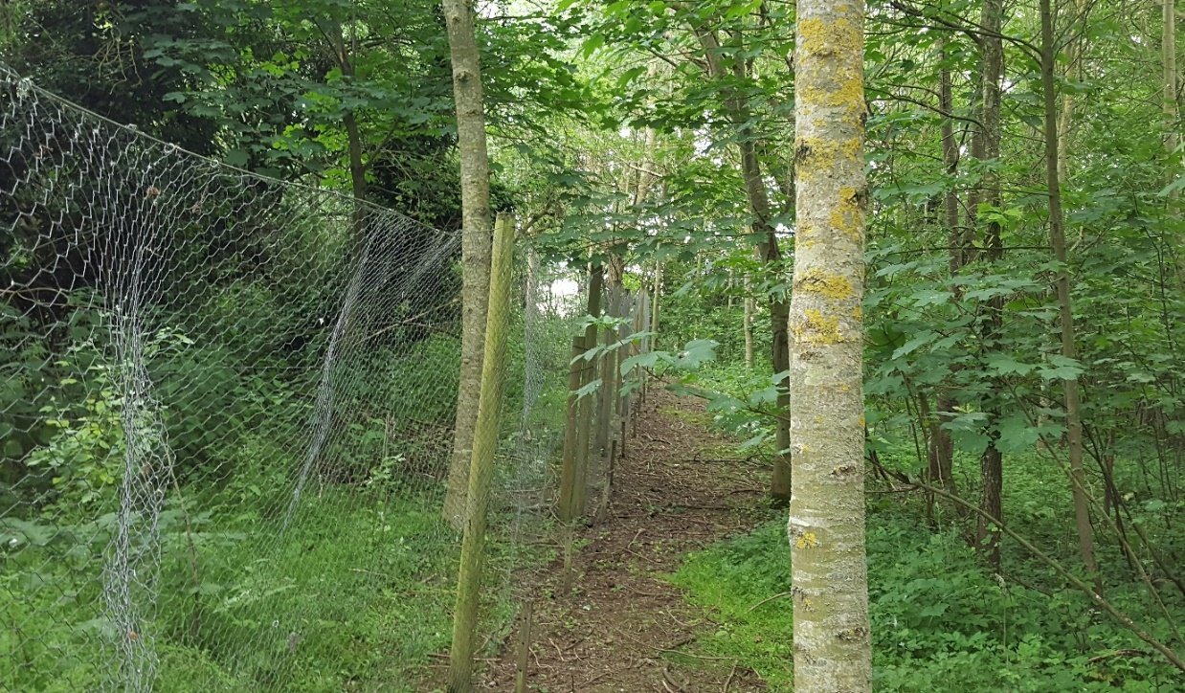
Plate 4 – Dense vegetation structure of ‘House’ woodland (Author’s own, 2018)

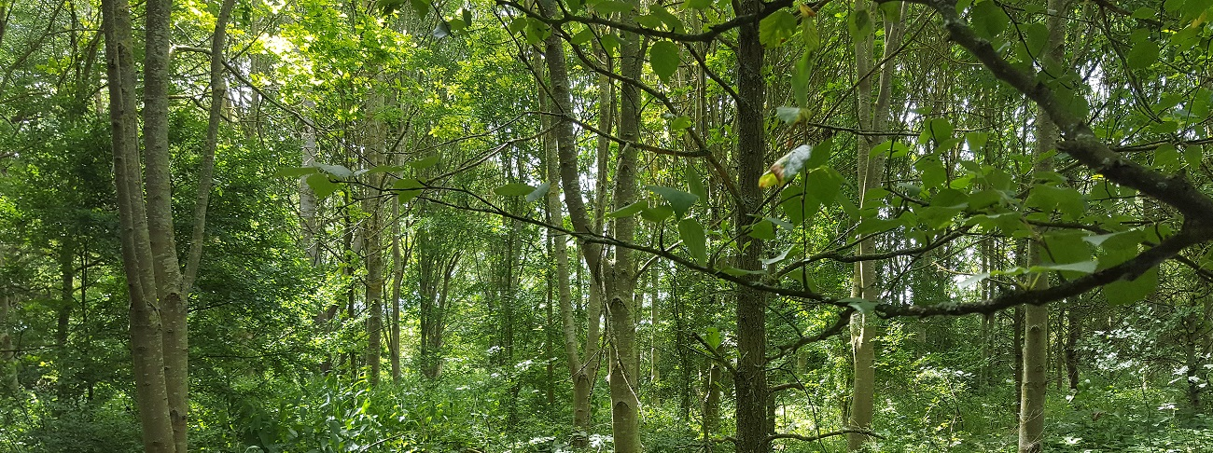
Plate 5 – Young trees & dense vegetation structure of ‘House’ woodland (Author’s own, 2018)
The above photographs (Plates 3-5) indicate the somewhat more open structure of this woodland compared with that of Skittle Green, however it is still relatively dense. MAGIC Maps (Figure 11) marks this woodland partly as being composed of young trees. It may thus be too young to harbour a significant number of Silphids. Furthermore, there was some evidence of pheasant management and an enclosure which may have reduced the ground availability by Silphids, but the author does not believe this to be a significant impact. Although this site is situated upon an incline, it is relatively exposed and may allow for easy landscape traversal, unlike Skittle Green. Equally, its lack of connections and the dominance of field systems around it may have resulted in lower Silphid numbers.

SKITTLE GREEN/SMALL 2
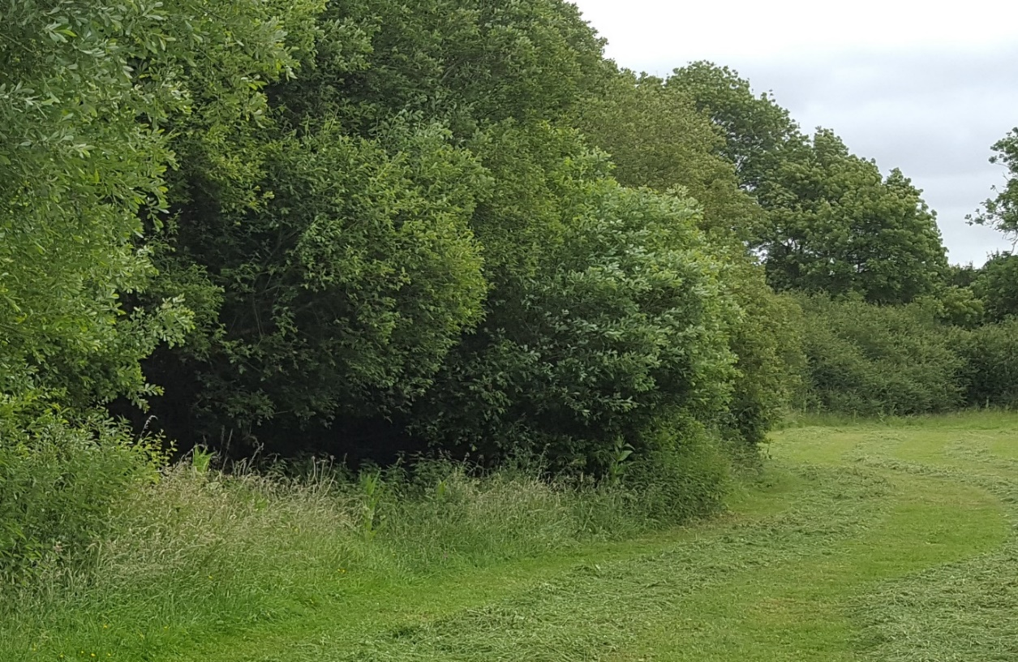
Plate 6 – Edge of ‘Skittle Green’ Woodland (Author’s own, 2018)
In Plate 6 can be seen the relatively dense and impenetrable edge of the woodland named Skittle Green. Again, this site was bounded by lines of tall trees and was relatively secluded.

EMMINGTON/LARGE 1
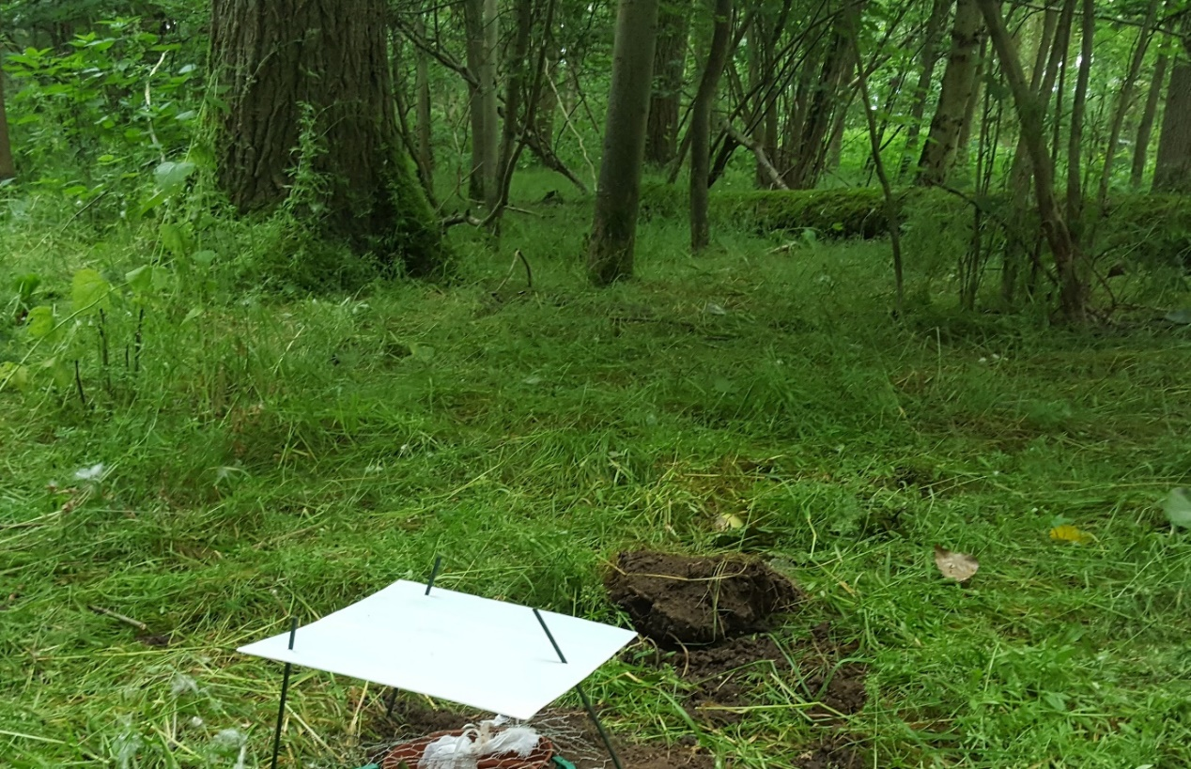
Plate 7 – Interior of ‘Emmington’ woodland (Author’s own, 2018)
ADWELL/LARGE 2
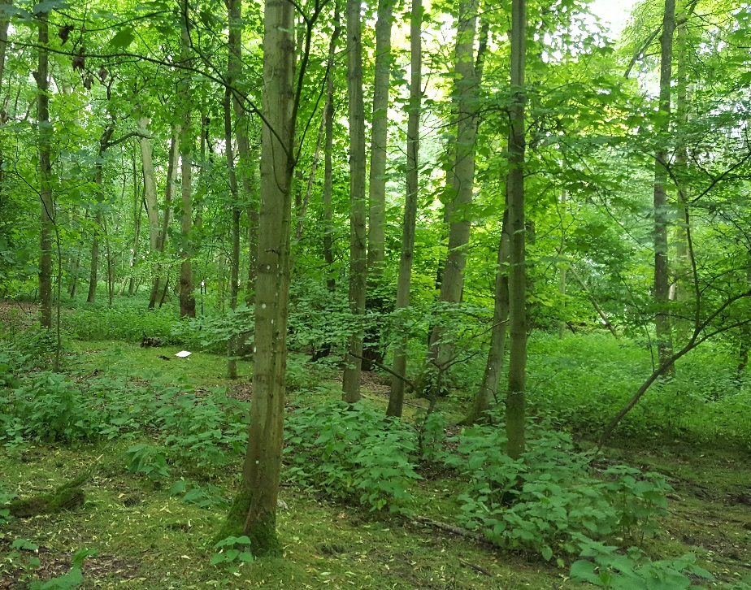
Plate 8 – Structure of ‘Adwell’ woodland (Author’s own, 2018)
Plates 7 & 8 highlight the more open and natural structure of ‘Emmington’ and ‘Adwell’, the two larger woodlands.
*The photography shown here is limited as analysis of each site’s structure was not the immediate concern during the period in which the study took place, in addition to the limited nature of the hypotheses under examination. The above plates show outdated materials from a short trial run as the author neglected to take further photographs upon full commencement of the study with the new materials.

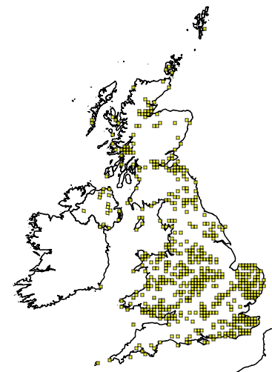
Common Woodland Silphid Distributions

Figure 8 – Nicrophorus humator records (NBN Atlas, n.d.)
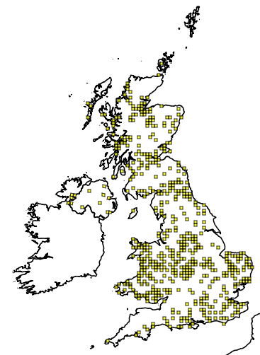

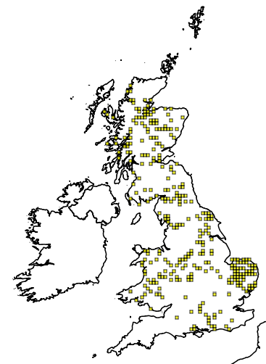
Figure 9 – Nicrophorus vespilloides records (NBN Atlas, n.d.)
Figure 10 – Oiceoptoma thoracicum records (NBN Atlas, n.d.)
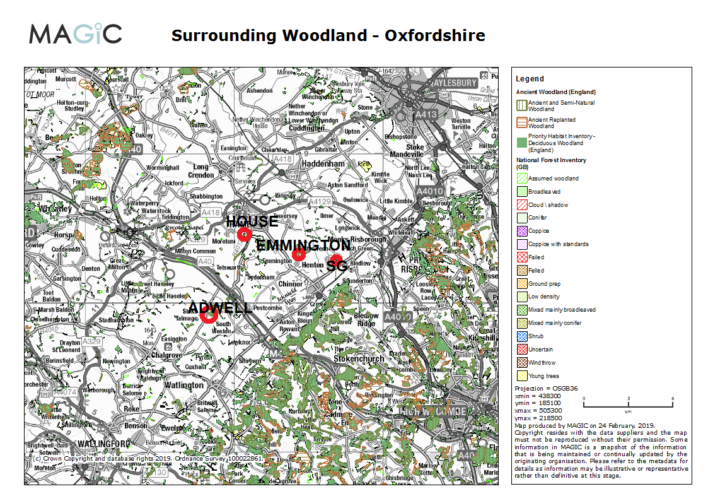
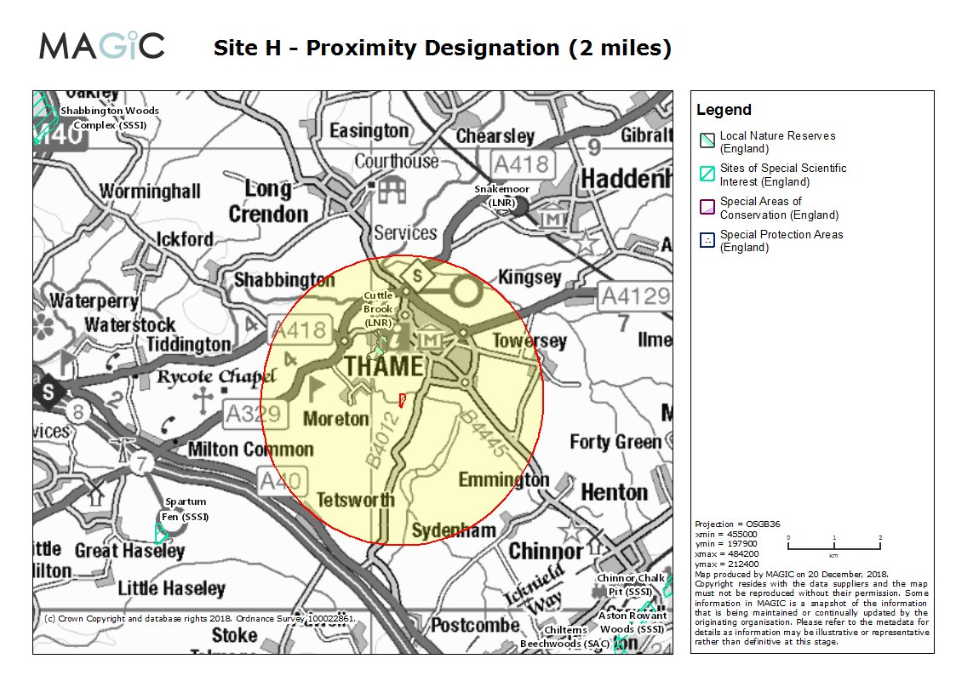
Figure 11 – Site surroundings and woodland extent (Natural England, 2019)
Figure 12 – House/Small 1 designations (Natural England, 2018)
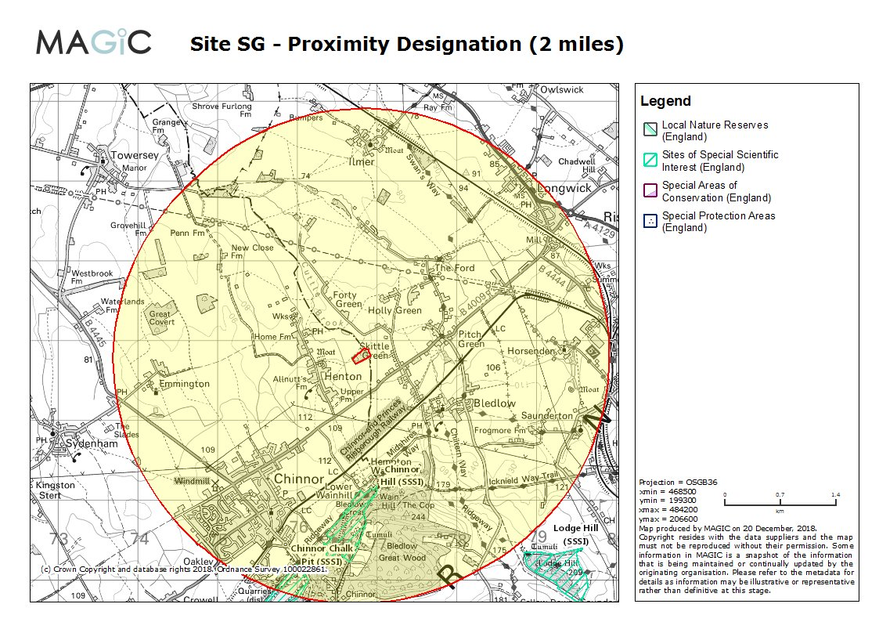
Figure 13 – Skittle Green/Small 2 designations (Natural England, 2018)
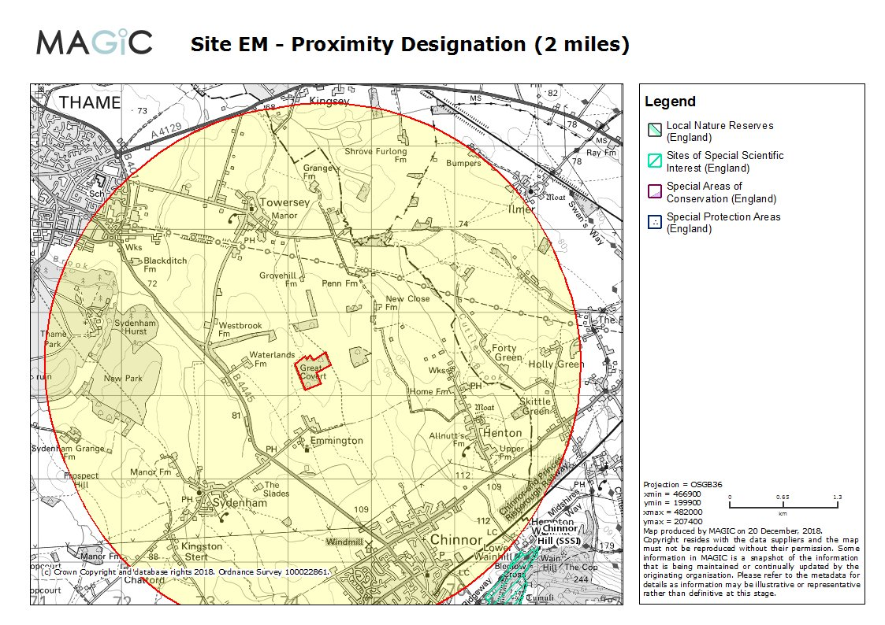
Figure 14 – Emmington/Large 1 designations (Natural England, 2018)
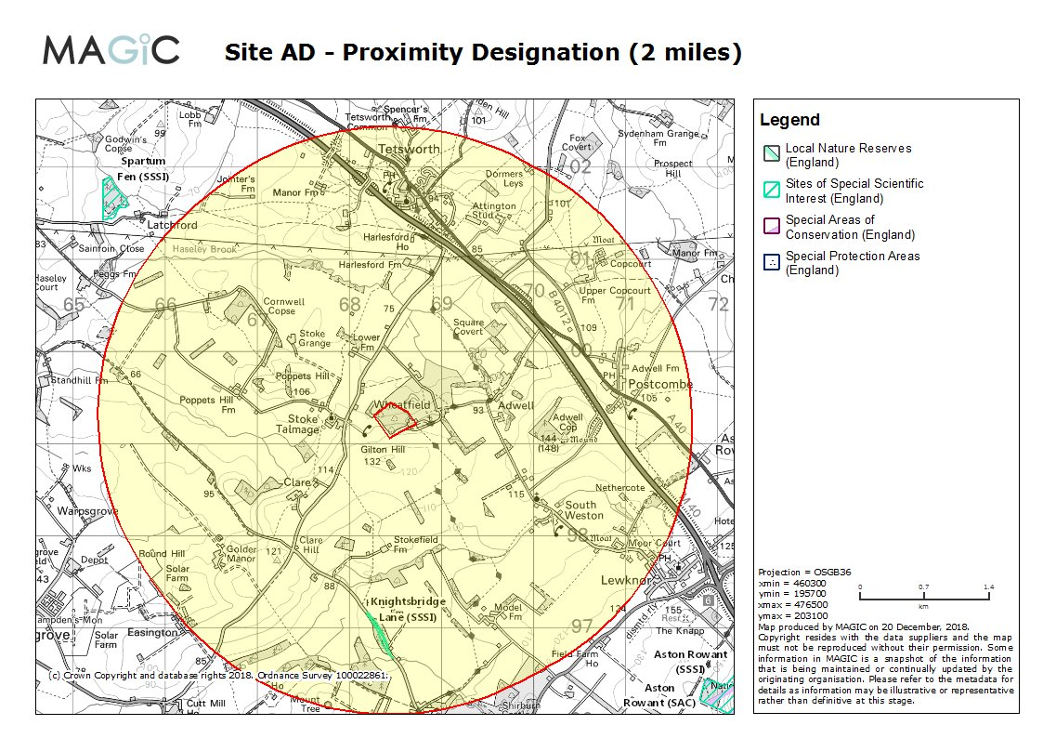
Figure 15 – Adwell/Large 2 designations (Natural England, 2018)

[C] Raw Data
Table 5 – Silphid Data Sheet
SITE | SIZE | VISIT | O. thoracicum | N. vespillo | N. vespilloides | N. humator | N. interruptus | N. investigator | T. rugosus | Abundance | Species Richness
Adwell | Large | 1 | 1 |  |  |  |  |  |  | 1 | 1
Emmington | Large | 1 |  |  | 1 |  |  |  |  | 1 | 1
House | Small | 1 |  |  |  |  |  |  |  | 0 | 0
Skittle Green | Small | 1 |  |  |  |  |  |  |  | 0 | 0
Adwell | Large | 2 |  |  |  |  |  |  |  | 0 | 0
Emmington | Large | 2 | 1 |  |  |  |  |  |  | 1 | 1
House | Small | 2 |  |  |  |  |  |  |  | 0 | 0
Skittle Green | Small | 2 |  |  |  |  |  |  |  | 0 | 0
Adwell | Large | 3 |  |  |  |  |  |  |  | 0 | 0
Emmington | Large | 3 | 1 |  | 1 |  |  |  |  | 2 | 2
House | Small | 3 |  |  |  |  |  |  |  | 0 | 0
Skittle Green | Small | 3 |  |  |  |  |  |  |  | 0 | 0
Adwell | Large | 4 | 1 |  |  |  |  |  |  | 1 | 1
Emmington | Large | 4 |  |  |  |  |  |  |  | 0 | 0
House | Small | 4 |  |  |  |  |  |  |  | 0 | 0
Skittle Green | Small | 4 |  | 2 |  |  |  |  |  | 2 | 1
Adwell | Large | 5 | 1 |  |  |  |  |  |  | 1 | 1
Emmington | Large | 5 | 4 |  | 1 |  |  |  |  | 5 | 2
House | Small | 5 | 1 |  |  |  |  |  |  | 1 | 1
Skittle Green | Small | 5 |  |  |  |  |  |  |  | 0 | 0
Adwell | Large | 6 |  |  |  |  |  |  |  | 0 | 0
Emmington | Large | 6 |  |  |  |  |  |  |  | 0 | 0
House | Small | 6 |  |  |  |  |  |  |  | 0 | 0
Skittle Green | Small | 6 |  |  |  | 2 |  |  |  | 2 | 1
Adwell | Large | 7 |  |  |  |  |  |  |  | 0 | 0
Emmington | Large | 7 |  |  |  |  |  |  |  | 0 | 0
House | Small | 7 |  |  |  |  |  |  |  | 0 | 0
Skittle Green | Small | 7 |  |  |  |  |  |  |  | 0 | 0
Adwell | Large | 8 |  |  |  |  |  |  |  | 0 | 0
Emmington | Large | 8 |  |  |  |  |  |  |  | 0 | 0
House | Small | 8 |  |  | 1 |  |  |  |  | 1 | 1
Skittle Green | Small | 8 |  |  |  |  |  |  |  | 0 | 0
Adwell | Large | 9 |  | 3 |  |  |  |  |  | 3 | 1
Emmington | Large | 9 | 1 |  |  |  |  |  |  | 1 | 1
House | Small | 9 |  |  | 1 |  |  |  |  | 1 | 1
Skittle Green | Small | 9 |  |  |  | 1 |  |  |  | 1 | 1
Adwell | Large | 10 | 2 | 1 |  | 1 | 1 | 1 |  | 6 | 5
Emmington | Large | 10 | 2 |  |  |  |  |  |  | 2 | 1
House | Small | 10 |  | 1 |  |  |  |  |  | 1 | 1
Skittle Green | Small | 10 |  |  |  |  |  |  |  | 0 | 0
Adwell | Large | 11 |  | 1 |  |  | 2 |  |  | 3 | 2
Emmington | Large | 11 | 2 | 1 |  |  |  |  |  | 3 | 2
House | Small | 11 |  |  |  |  |  |  |  | 0 | 0
Skittle Green | Small | 11 |  |  |  | 2 |  |  |  | 2 | 1
Adwell | Large | 12 | 1 | 1 |  |  |  |  |  | 2 | 2
Emmington | Large | 12 | 4 | 1 | 1 |  |  |  |  | 6 | 3
House | Small | 12 |  |  |  |  | 1 |  | 1 | 2 | 2
Skittle Green | Small | 12 |  |  |  |  | 1 |  |  | 1 | 1
Adwell | Large | 13 | 6 |  |  |  |  |  |  | 6 | 1
Emmington | Large | 13 |  |  |  |  |  |  |  | 0 | 0
House | Small | 13 |  | 1 |  |  | 1 |  |  | 2 | 2
Skittle Green | Small | 13 |  |  |  |  |  |  |  | 0 | 0
Adwell | Large | 14 | 2 |  | 1 |  | 3 |  |  | 6 | 3
Emmington | Large | 14 | 1 |  |  |  |  |  |  | 1 | 1
House | Small | 14 |  | 1 |  | 1 |  |  |  | 2 | 2
Skittle Green | Small | 14 |  |  |  |  |  |  |  | 0 | 0
Adwell | Large | 15 | 2 |  |  | 1 | 3 |  |  | 6 | 3
Emmington | Large | 15 | 3 |  | 1 |  | 1 |  |  | 5 | 3
House | Small | 15 |  | 2 |  |  |  |  |  | 2 | 1
Skittle Green | Small | 15 |  |  |  |  |  | 1 |  | 1 | 1
Adwell | Large | 16 |  |  |  | 1 |  |  |  | 1 | 1
Emmington | Large | 16 | 2 |  |  |  |  |  |  | 2 | 1
House | Small | 16 |  |  |  | 1 |  |  |  | 1 | 1
Skittle Green | Small | 16 |  |  |  |  |  |  |  | 0 | 0
Adwell | Large | 17 |  |  | 2 |  |  |  |  | 2 | 1
Emmington | Large | 17 | 1 |  |  |  |  |  |  | 1 | 1
House | Small | 17 |  |  |  | 3 | 1 |  | 2 | 6 | 3
Skittle Green | Small | 17 |  |  |  |  |  | 1 |  | 1 | 1
Adwell | Large | 18 |  |  | 1 |  |  |  |  | 1 | 1
Emmington | Large | 18 |  |  | 1 |  |  |  |  | 1 | 1
House | Small | 18 |  | 2 |  |  |  |  |  | 2 | 1
Skittle Green | Small | 18 |  |  |  |  |  |  |  | 0 | 0
Adwell | Large | 19 | 2 |  |  |  |  |  |  | 2 | 1
Emmington | Large | 19 |  |  |  |  |  |  |  | 0 | 0
House | Small | 19 |  | 3 |  |  |  |  |  | 3 | 1
Skittle Green | Small | 19 |  |  | 2 |  |  |  |  | 2 | 1
Adwell | Large | 20 | 1 |  | 2 |  |  |  |  | 3 | 2
Emmington | Large | 20 | 3 |  |  |  |  |  |  | 3 | 1
House | Small | 20 |  | 2 |  |  |  |  |  | 2 | 1
Skittle Green | Small | 20 |  |  |  |  |  |  |  | 0 | 0
Adwell | Large | 21 | 1 |  |  |  |  |  |  | 1 | 1
Emmington | Large | 21 |  |  |  |  |  |  |  | 0 | 0
House | Small | 21 |  |  |  |  |  |  | 1 | 1 | 1
Skittle Green | Small | 21 |  |  |  |  |  |  |  | 0 | 0
Adwell | Large | 22 |  |  |  |  |  |  |  | 0 | 0
Emmington | Large | 22 |  |  |  |  |  |  |  | 0 | 0
House | Small | 22 |  |  |  |  |  |  |  | 0 | 0
Skittle Green | Small | 22 |  |  |  |  |  |  |  | 0 | 0
Adwell | Large | 23 |  | 1 |  |  | 1 |  |  | 2 | 2
Emmington | Large | 23 | 1 |  | 2 |  |  |  |  | 3 | 2
House | Small | 23 |  | 1 |  |  |  |  |  | 1 | 1
Skittle Green | Small | 23 |  |  |  |  |  |  |  | 0 | 0
Adwell | Large | 24 |  |  | 1 |  | 2 |  |  | 3 | 2
Emmington | Large | 24 | 2 |  |  |  |  |  |  | 2 | 1
House | Small | 24 |  |  | 1 |  |  |  |  | 1 | 1
Skittle Green | Small | 24 |  |  |  |  |  |  |  | 0 | 0
Adwell | Large | 25 |  |  |  |  | 2 |  |  | 2 | 1
Emmington | Large | 25 |  |  | 2 |  |  |  |  | 2 | 1
House | Small | 25 |  |  |  |  |  |  |  | 0 | 0
Skittle Green | Small | 25 |  |  |  |  |  |  |  | 0 | 0
Adwell | Large | 26 |  |  |  |  |  |  |  | 0 | 0
Emmington | Large | 26 | 1 |  |  |  |  |  |  | 1 | 1
House | Small | 26 |  |  |  |  |  |  |  | 0 | 0
Skittle Green | Small | 26 | 1 |  |  |  |  |  |  | 1 | 1
Adwell | Large | 27 |  | 2 |  |  |  |  |  | 2 | 1
Emmington | Large | 27 | 1 |  |  |  |  |  |  | 1 | 1
House | Small | 27 |  |  |  |  | 1 |  |  | 1 | 1
Skittle Green | Small | 27 |  |  |  |  |  |  |  | 0 | 0
Adwell | Large | 28 | 1 |  |  |  |  |  |  | 1 | 1
Emmington | Large | 28 |  |  |  | 4 |  | 3 |  | 7 | 2
House | Small | 28 | 3 | 2 |  |  |  |  |  | 5 | 2
Skittle Green | Small | 28 | 3 |  |  |  |  |  |  | 3 | 1

[D] Test Outputs & Post Hoc Methodology

Minitab Outputs
Silphid Abundance
Null hypothesis | H₀: All treatment effects are zero
Alternative hypothesis | H₁: Not all treatment effects are zero

Method | DF | Chi-Square | P-Value
Not adjusted for ties | 3 | 14.34 | 0.002
Adjusted for ties | 3 | 18.16 | 0.000

Silphid Species Richness
Null hypothesis | H₀: All treatment effects are zero
Alternative hypothesis | H₁: Not all treatment effects are zero

Method | DF | Chi-Square | P-Value
Not adjusted for ties | 3 | 12.12 | 0.007
Adjusted for ties | 3 | 17.67 | 0.001

Post hoc Analysis
There are several different post hoc methods which may be used after the rejection of a null hypothesis using the Friedman test, such as the Conover or Nemenyi, and it is not generally agreed which is more optimal (Zaiontz, 2019; Dytham, 2011). The following manual method is believed to use the Wilcoxon Rank Sum test as its basis.
Analysis was carried out in the following fashion:
- A matrix was formulated whereby the differences between each site could be calculated, as shown by the example in Table 6.
- A threshold value was calculated using the formula:
z* √[(N(N+1)/12)*(1/n1+1/n2)]
- z = area under standard normal distribution
- N = total number of data points in whole analysis
- n₁ = number of data points in group 1
- n₂ = number of data points in group 2
  - This study had four groups, as a result of which six pairwise comparisons were made (Table 7)
- Differences were then compared to the threshold value (e.g. Cell A1 – Cell A2). Differences larger than the threshold value were left blank to indicate that the two groups were different from one another. This is because the disparity between the two values is greater than would be expected by chance (the outcome is non-random in nature). Those sites which were smaller than the threshold value were given a letter signifying their non-significance. Letters were also given if the comparison could not be carried out (e.g. A – A) (Table 8).
- Post hoc pairings were then simplified (Table 9) (discarding unnecessary letters) by identifying whether any letters in different columns ended on the same row, thereby providing the same information.
- Post hoc groups were lastly identified by reading across the rows.
- The method described above was the same for both species richness and abundance variables.

Table 6 – Example of post hoc differences matrix
 | Adwell (a) | Emmington (b) | House ( c ) | Skittle Green (d)
Adwell (a)
Emmington (b) | 3
House ( c ) | 14 | 11
Skittle Green (d) | 33 | 30 | 19

Table 7 – Z Table (Threshold Value)
Number of groups | Number of comparisons | α=0.05 (two-tailed)
2 | 1 | 1.96
3 | 3 | 2.394
4 | 6 | 2.638
5 | 10 | 2.807
6 | 15 | 2.935
7 | 21 | 3.038
8 | 28 | 3.125
9 | 36 | 3.18
10 | 45 | 3.3
11 | 55 | 3.3
12 | 66 | 3.4
13 | 78 | 3.4
14 | 91 | 3.5
15 | 105 | 3.5
16 | 120 | 3.5

Table 8 – Example of post hoc letters application
 | Adwell (a) | Emmington (b) | House ( c ) | Skittle Green (d)
Adwell (a) | A
Emmington (b) | A | B
House ( c ) | A | B | C
Skittle Green (d) |  |  | C | D

Table 9 – Example of post hoc letters simplification
 | Adwell (a) | Emmington (b) | House ( c ) | Skittle Green (d)
Adwell (a) | A
Emmington (b) | A | B
House ( c ) | A | B
Skittle Green (d) |  |  | C

[E] Site Access & Health and Safety
Access permission was attained prior to the commencement of the study via personal communication with landowners. Due to the practical nature of the study and the risks involved with the preparation of bait and setting of traps preventative measures were vital. Please see the risk assessment attached.
